Day64-66 - Task31 - Terraform(Part-2)

1.Execute all the templates shown in the video?
1. Create the Terraform project
Create a directory:
Windows PowerShell
mkdir Terraform_basic
cd Terraform_basic
Check: pwd
2. First template — local_file
The first important resource in the video is:
resource "local_file" "my_pet" {
filename = "pets.txt"
content = "My cat name is HEN"
}
What does it do?
Terraform creates a local file: pets.txt
Containing: My cat name is HEN
Step 1 — Create main.tf
notepad main.tf
Put:
resource "local_file" "my_pet" {
filename = "pets.txt"
content = "My cat name is HEN"
}
Save the file.
3. Initialize Terraform
Run:
terraform init
Terraform downloads the required provider.
You should see:
Terraform has been successfully initialized! 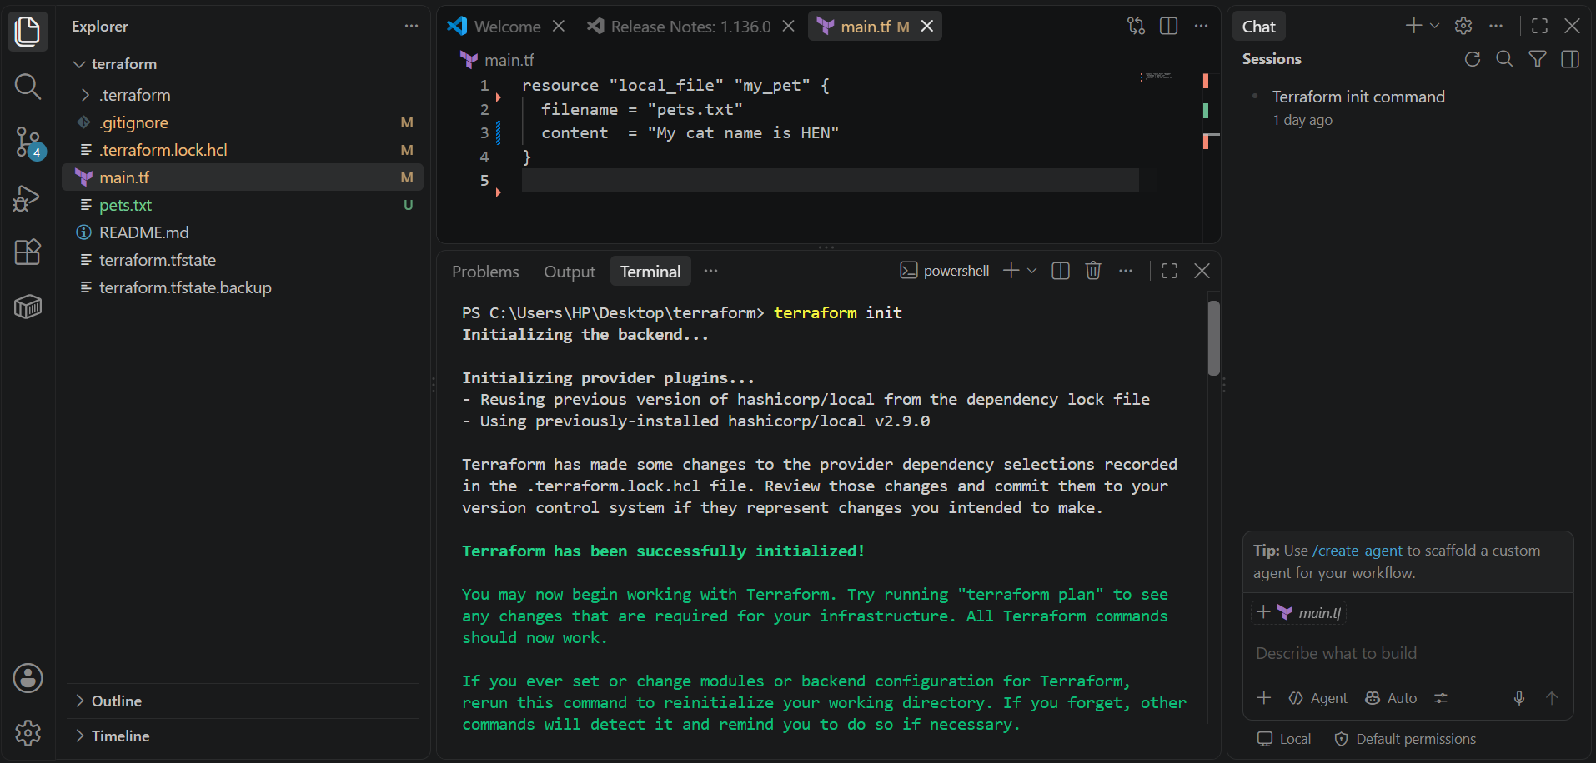
4. Validate
Run:
terraform validate
Expected:
Success! The configuration is valid.
5. Format
Run:
terraform fmt
6. Plan
Run:
terraform plan
You should see something similar to: Plan: 1 to add, 0 to change, 0 to destroy.
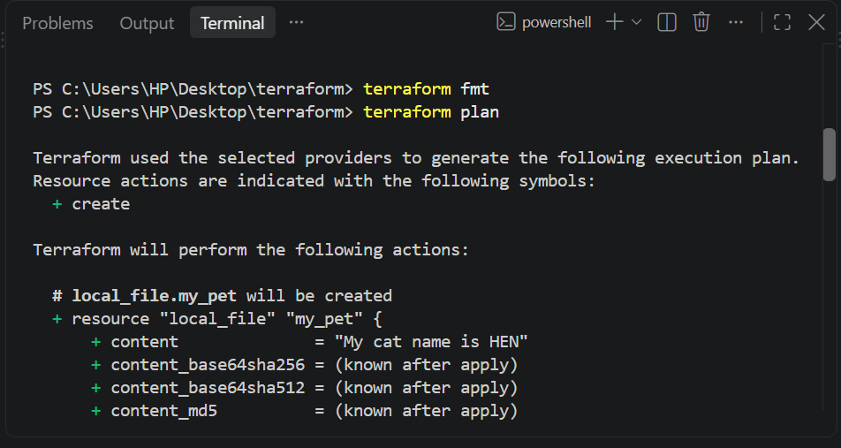
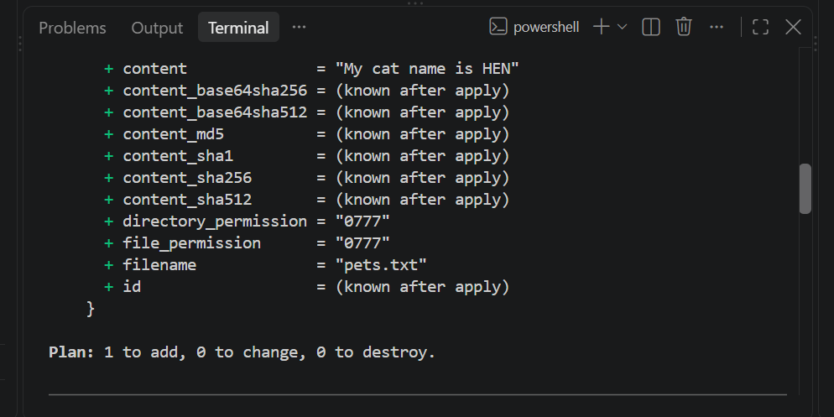
7. Apply
Run:
terraform apply
Terraform asks: Do you want to perform these actions?
Enter: yes
You should get: Apply complete! Resources: 1 added, 0 changed, 0 destroyed. 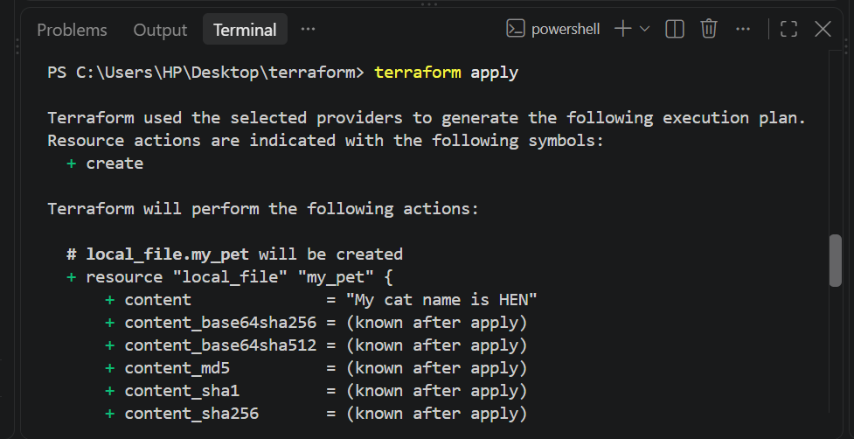 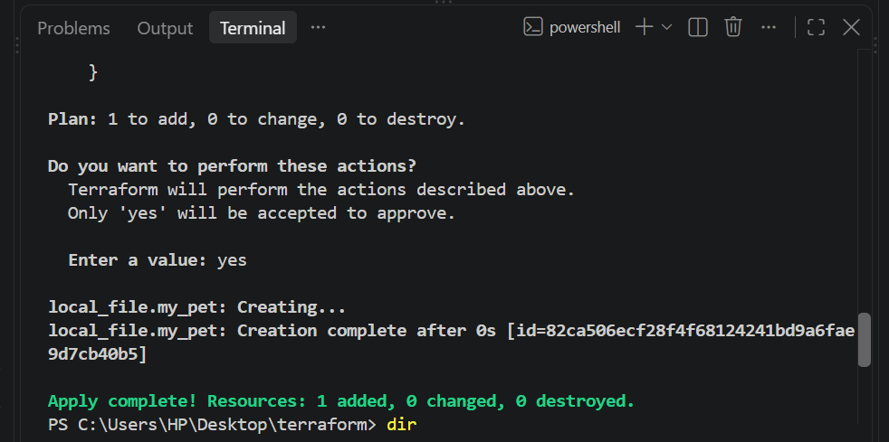
Now check: dir
You should see: main.tf
pets.txt
terraform.tfstate 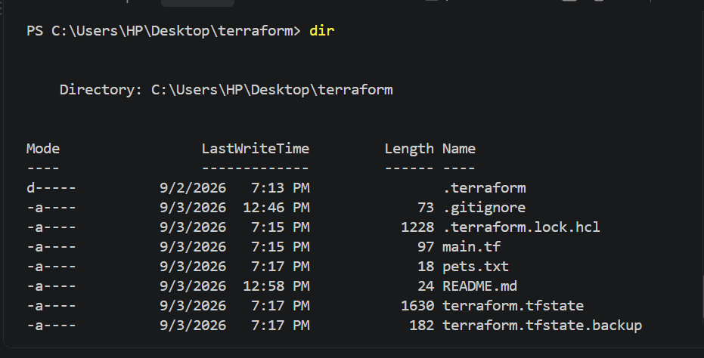
Open:
type pets.txt
Output:
My cat name is HEN 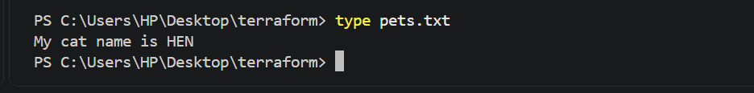
8. Second template — random_pet
The video then introduces the random_pet resource.
The template is:
resource "random_pet" "petname" {
prefix = "MR"
separator = "."
length = 1
}
This creates a random pet name such as:
MR.spaniel
or:
MR.gazelle
The exact result is random.
9. Use both resources together
The video has:
resource "local_file" "my_pet" {
filename = "pets.txt"
content = "My cat name is HEN"
}

resource "random_pet" "petname" {
prefix = "MR"
separator = "."
length = 1
} 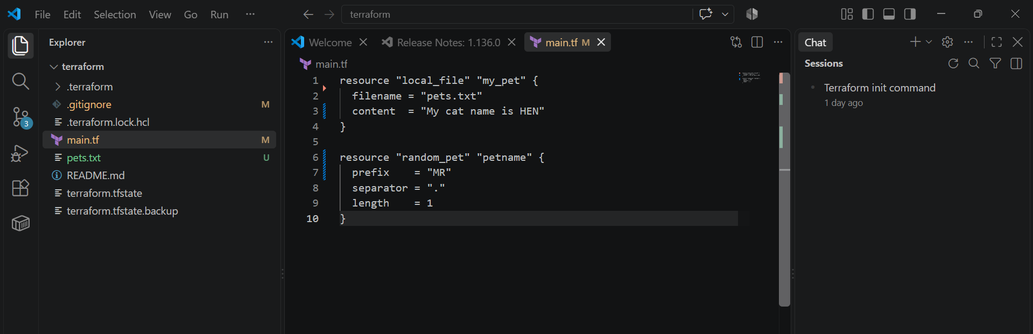
Put this into main.tf.
Then:
Terraform init
terraform fmt
terraform validate
terraform plan
terraform apply
Enter:
yes 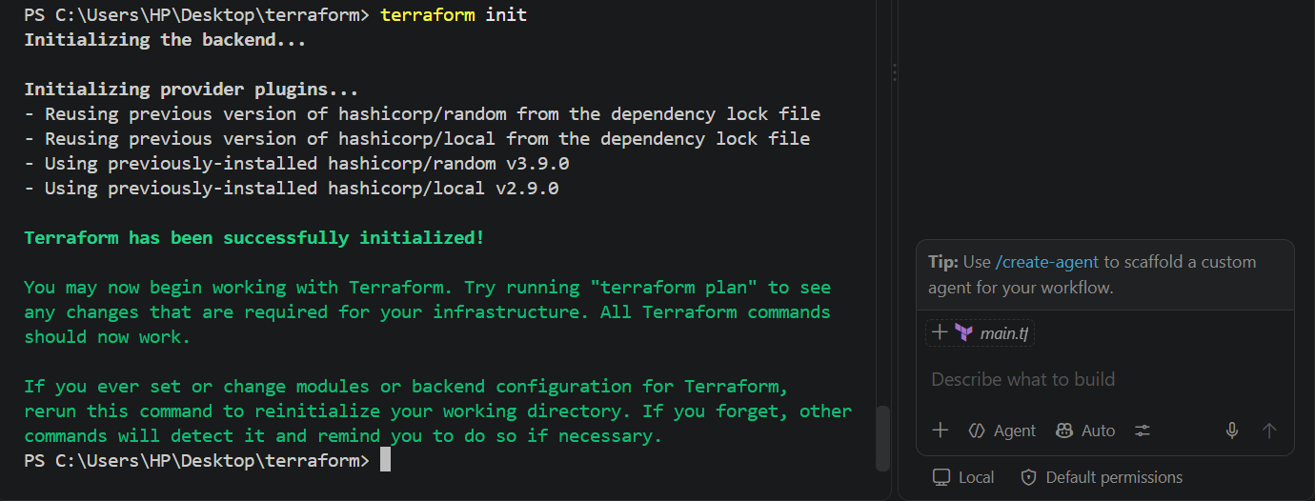 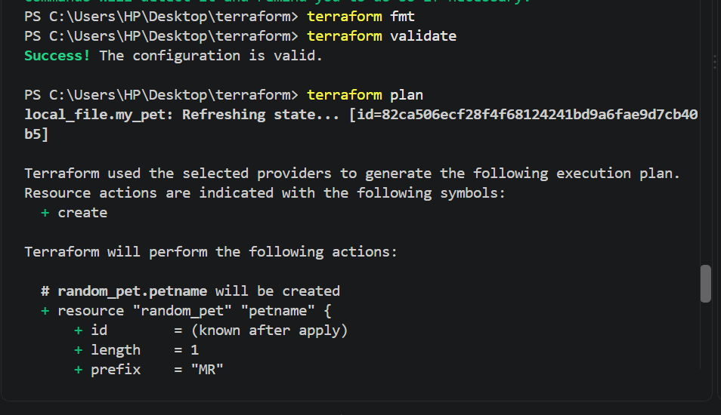 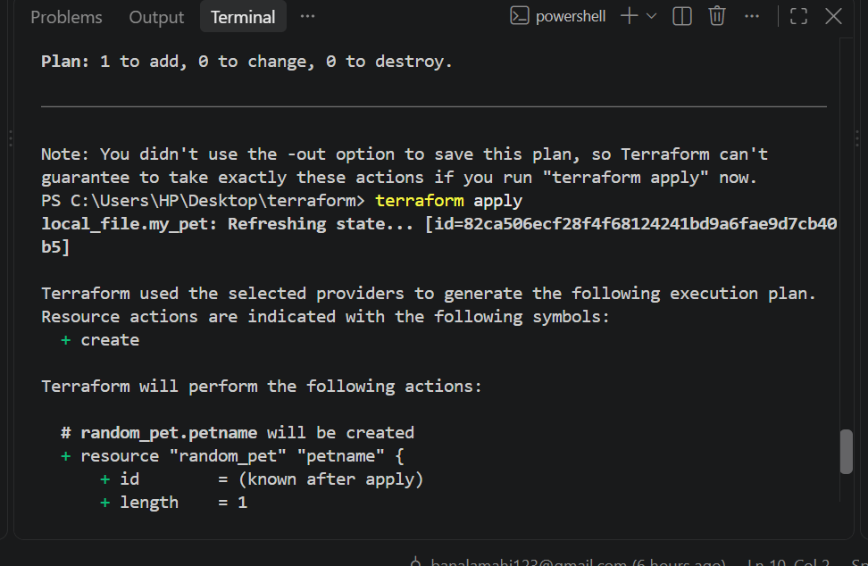 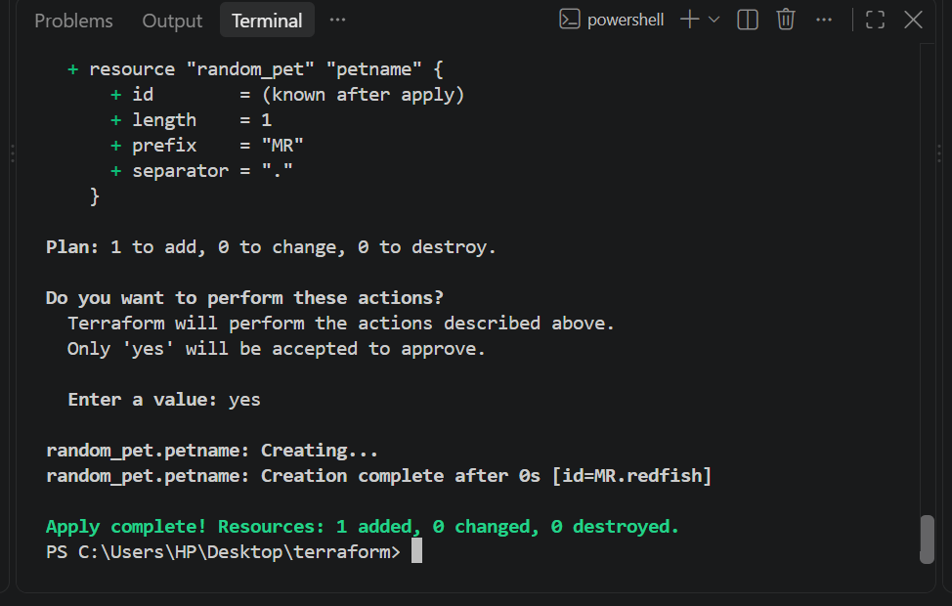
Now Terraform manages two resources: local_file.my_pet, random_pet.petname
Check: terraform state list
Expected: local_file.my_pet
random_pet.petname 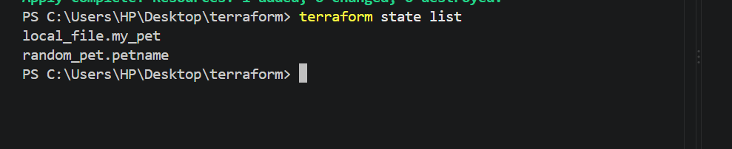

10. Understand Terraform State
After terraform apply, Terraform creates: terraform.tfstate
The video opens this file to show that Terraform stores information about the resources it manages.
You can inspect the state with: terraform show
Or: terraform state list
For example: local_file.my_pet
random_pet.petname
Important
Don't manually edit: terraform.tfstate
Use Terraform commands to manage state.

11. Change the local_file
The video changes the content several times.
For example:
resource "local_file" "my_pet" {
filename = "pets.txt"
content = "My cat name is DOG"
}

resource "random_pet" "petname" {
prefix = "MR"
separator = "."
length = 1
} 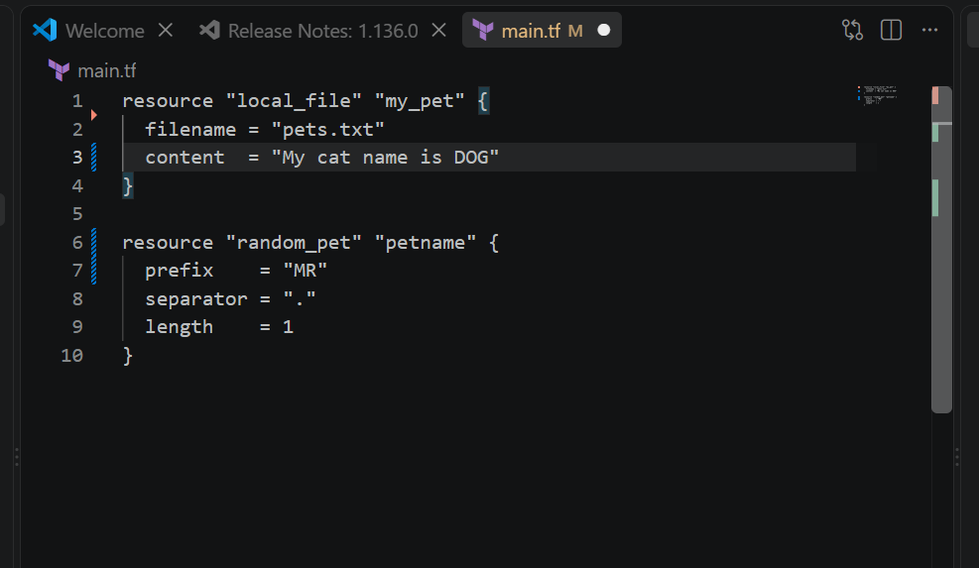
Run:
terraform plan
Terraform detects that the file needs to be replaced. 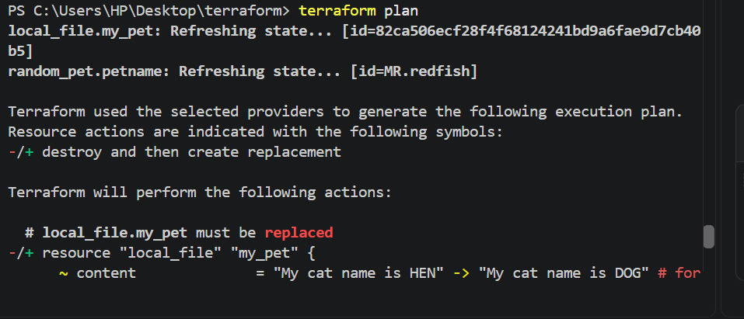
Then:
terraform apply
Enter:
yes 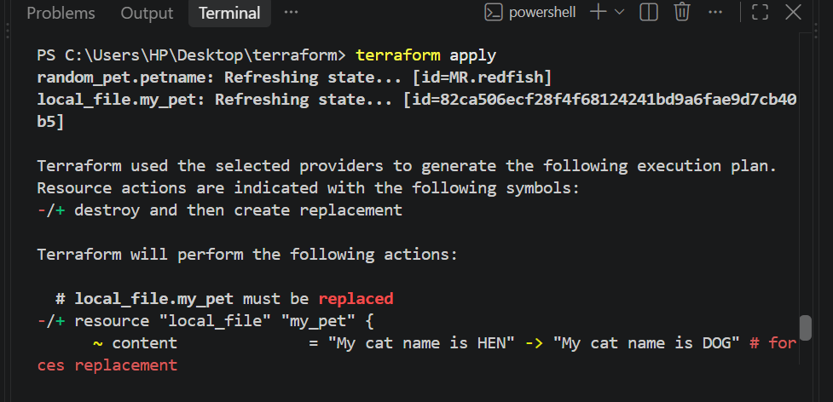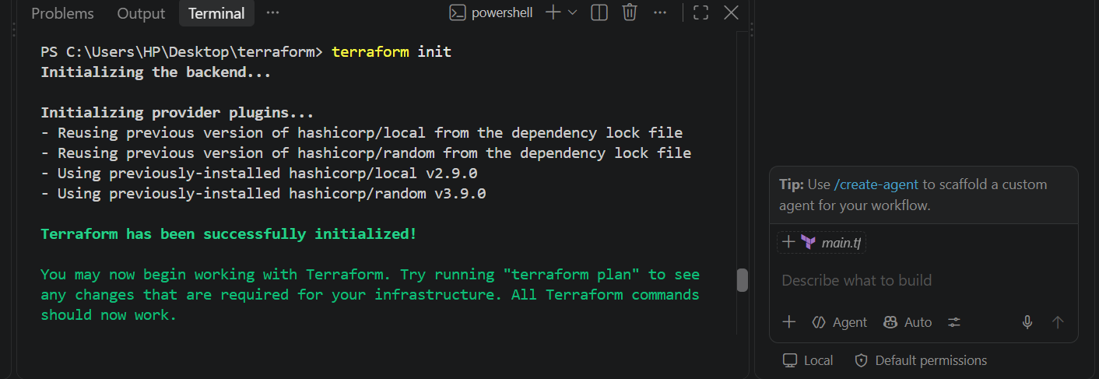
Terraform shows something like:
local_file.my_pet: Destroying...
local_file.my_pet: Creating...
This leads to the lifecycle rules section.
12. Mutable vs Immutable Infrastructure
The video explains:
Mutable infrastructure
Existing infrastructure is modified.
Existing resource
↓
Modify
↓
Same resource
Immutable infrastructure
Instead of modifying the existing resource:
Old resource
↓
Create replacement
↓
Destroy old resource
Terraform commonly uses this replacement behavior when an attribute requires a resource to be recreated.
13. Lifecycle Rules
The video discusses three important lifecycle rules:
create_before_destroy
prevent_destroy
ignore_changes
These are written inside:
lifecycle {
}
14. Template 1 — create_before_destroy
The video uses:
resource "local_file" "my_pet" {
filename = "pets.txt"
content = "My cat name is DOG"

lifecycle {
create_before_destroy = true
}
}
The important line is:
create_before_destroy = true
Normally, Terraform may do:
Destroy old
↓
Create new
With:
create_before_destroy = true
Terraform tries:
Create new
↓
Destroy old
This is useful for resources where downtime should be minimized.

Execute it
Replace your main.tf with:
resource "local_file" "my_pet" {
filename = "pets.txt"
content = "My cat name is DOG"

lifecycle {
create_before_destroy = true
}
}
resource "random_pet" "petname" {
prefix = "MR"
separator = "."
length = 1
}
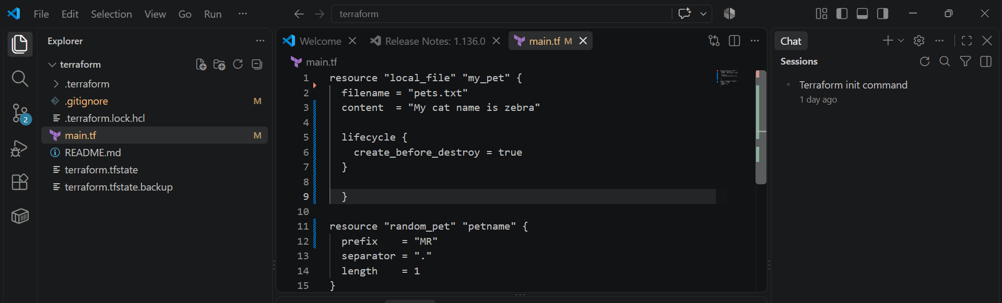
Now:
terraform fmt
terraform validate
terraform plan
terraform apply 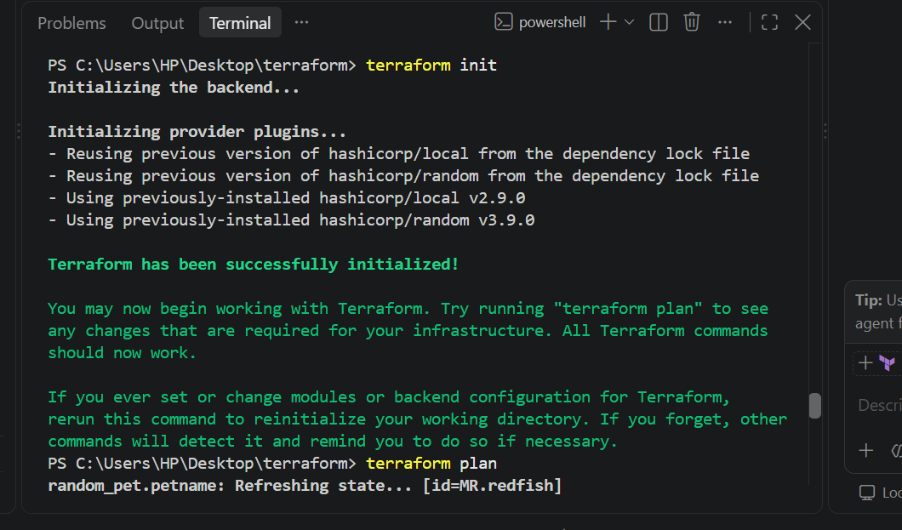 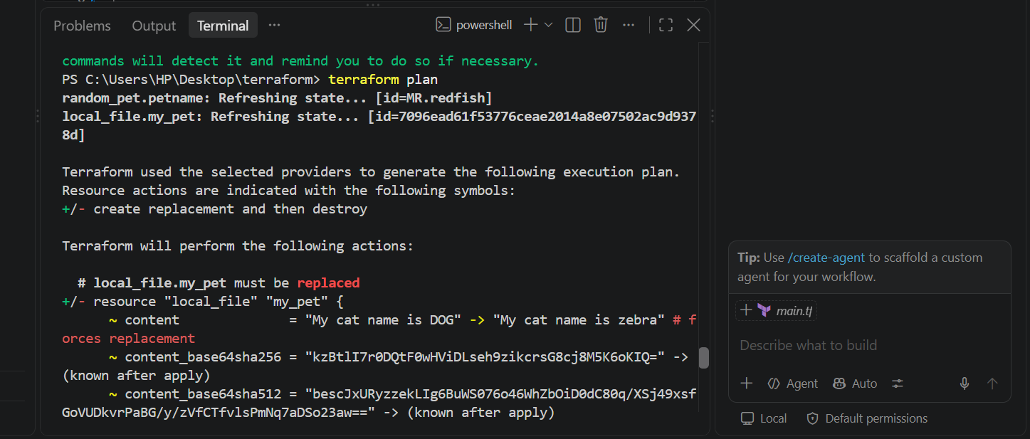 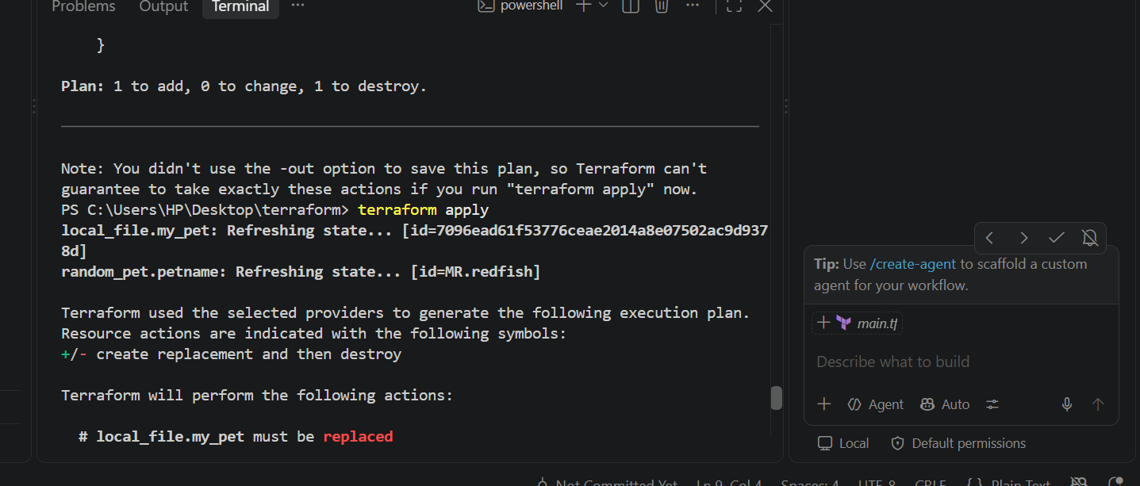 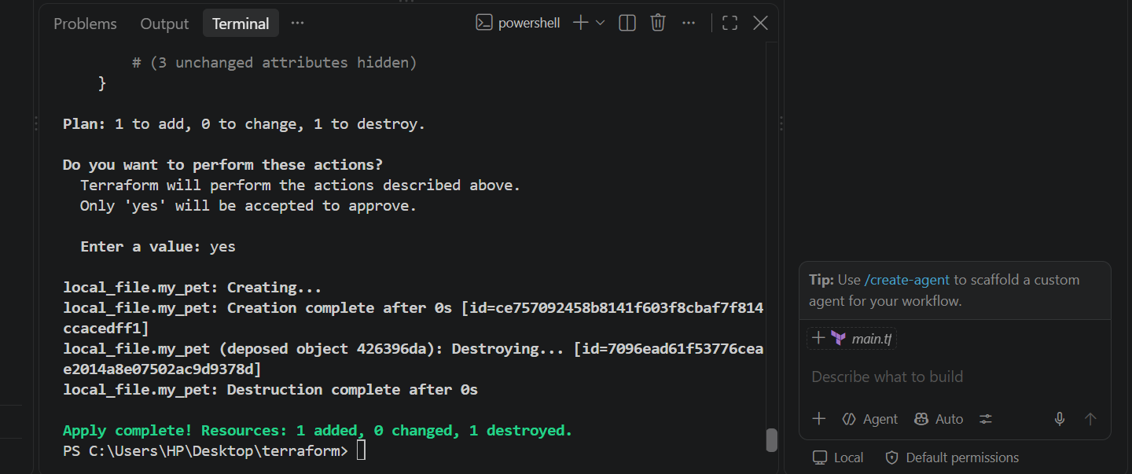

15. Template 2 — prevent_destroy
The video then demonstrates:
resource "local_file" "my_pet" {
filename = "pets.txt"
content = "My cat name is MR.CAT"

lifecycle {
prevent_destroy = true
}
}
This means:
Don't allow Terraform to destroy this resource while this configuration still has prevent_destroy = true.

Execute it
Change main.tf:
resource "local_file" "my_pet" {
filename = "pets.txt"
content = "My cat name is MR.CAT"

lifecycle {
prevent_destroy = true
}
} 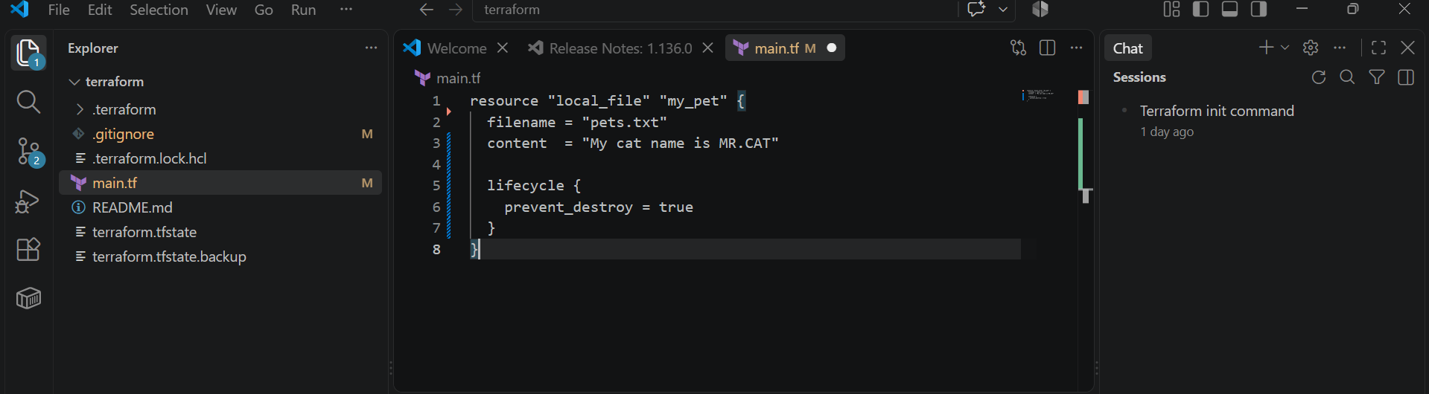
Run:
terraform fmt
terraform validate
terraform plan 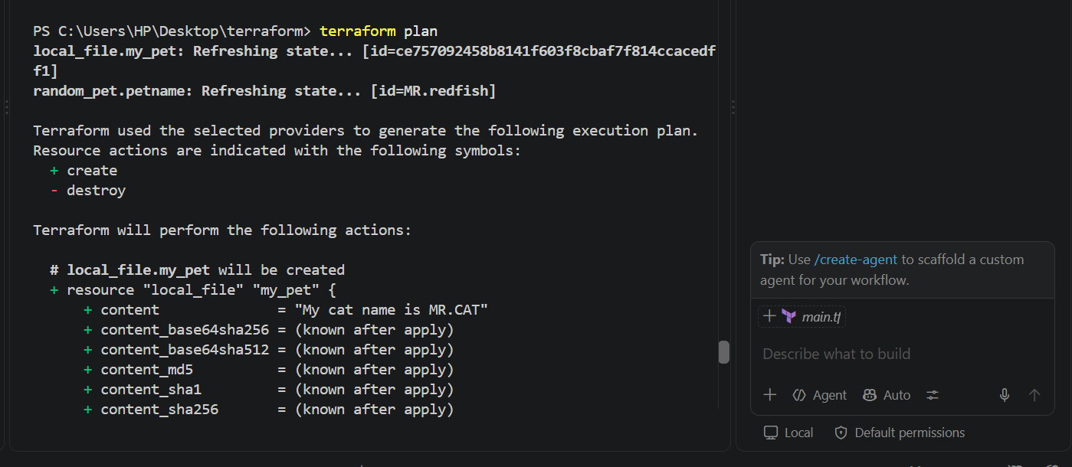 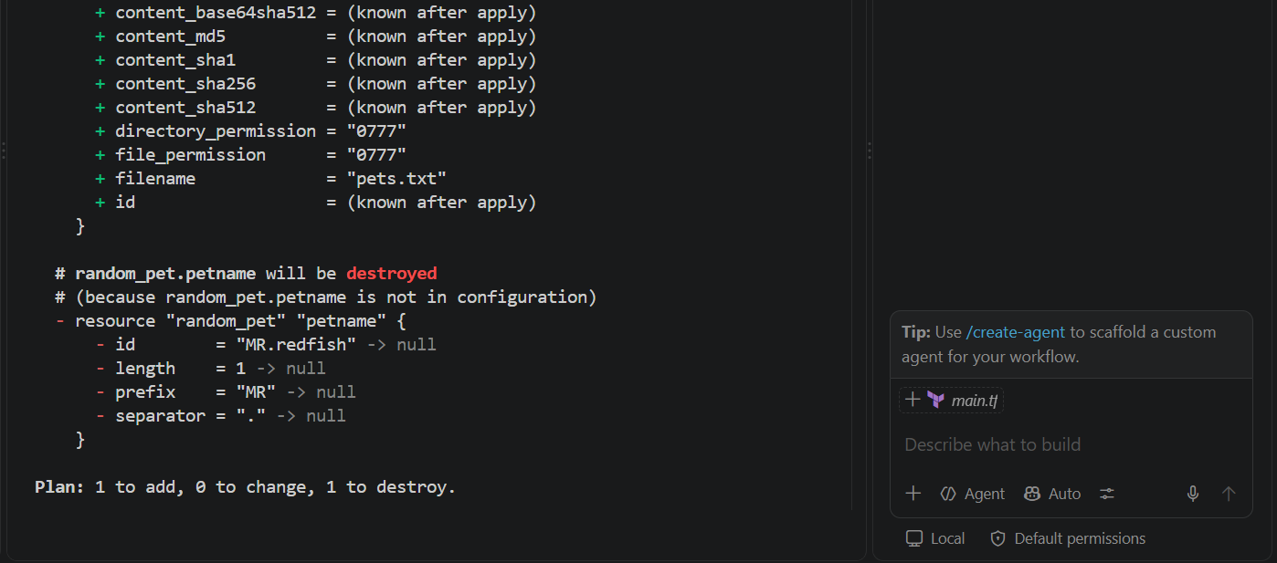
terraform apply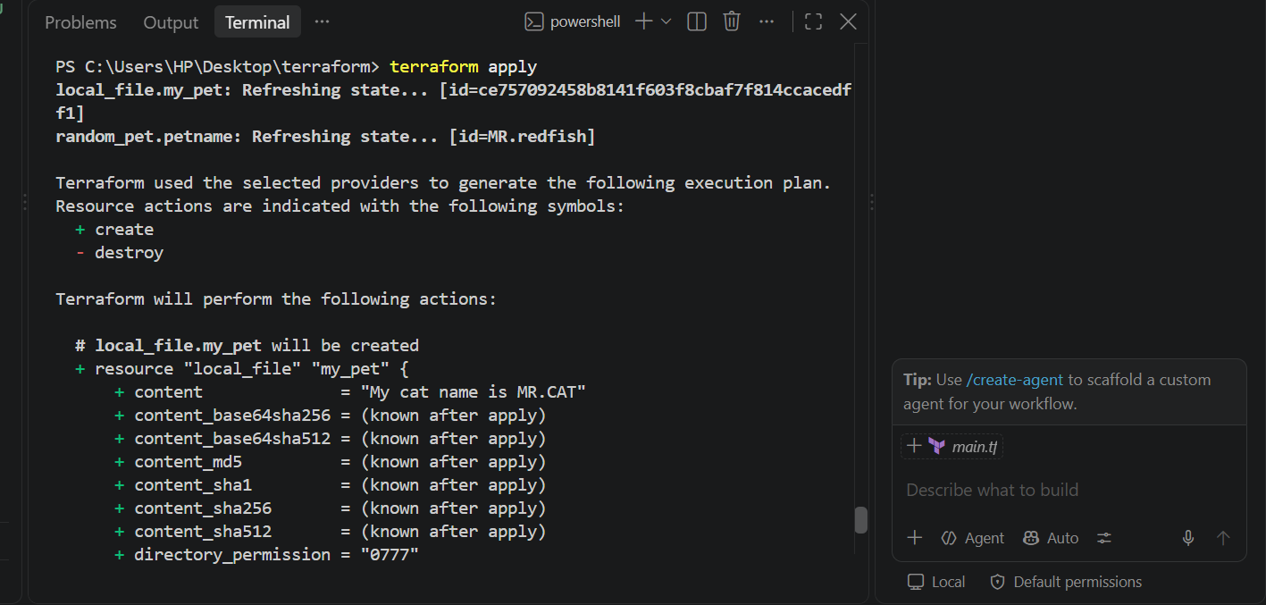 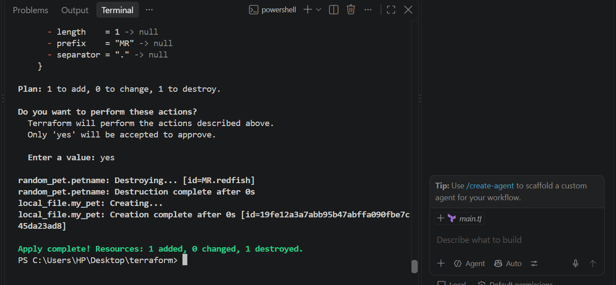
Now try:
terraform destroy
Terraform should prevent the destruction and report that the resource has a prevent_destroy lifecycle setting. 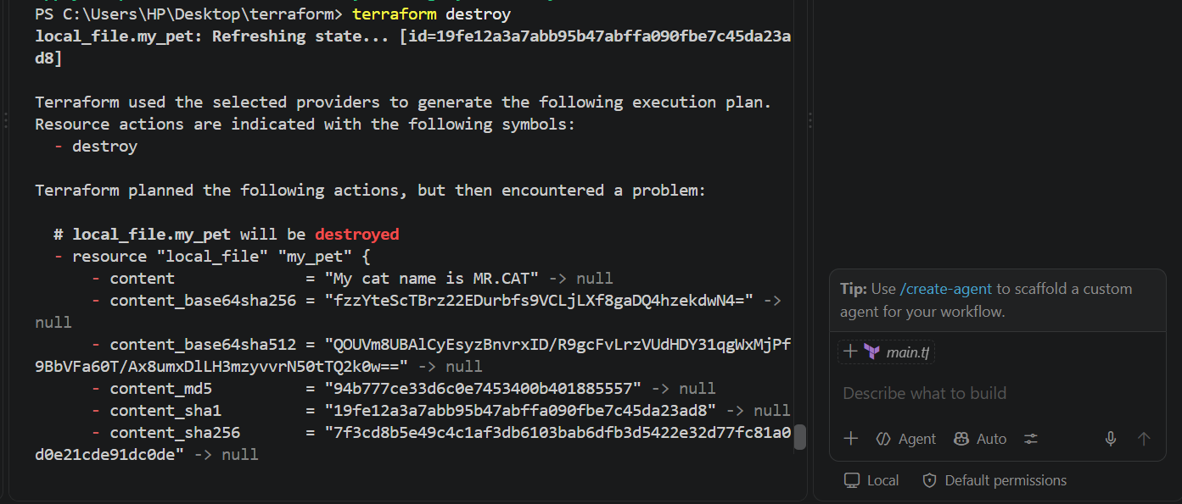 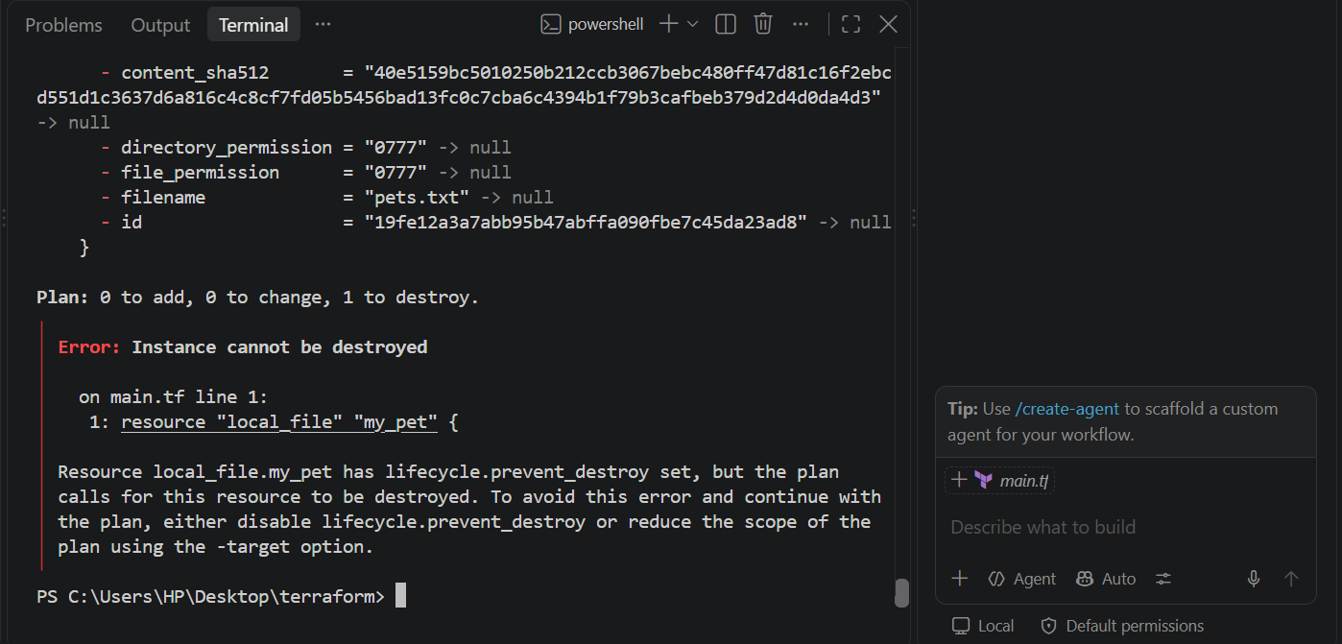
Important
prevent_destroy is a safety mechanism.
It's useful for important resources such as:
Production database
Production storage
Critical infrastructure
Important nuance: if you remove the resource from the configuration entirely, Terraform no longer has the lifecycle block to protect it. So prevent_destroy isn't a permanent protection against every possible deletion.

16. Template 3 — ignore_changes
This is another major example from the video.
The video first shows:
resource "local_file" "my_pet" {
filename = "pets.txt"
content = "My cat name is BANANA"

lifecycle {
ignore_changes = [
content
]
}
}
The idea is:
Ignore changes to the resource when Terraform calculates whether an update is required.

Execute it
Use:
resource "local_file" "my_pet" {
filename = "pets.txt"
content = "My cat name is BANANA"

lifecycle {
ignore_changes = [
content
]
}
} 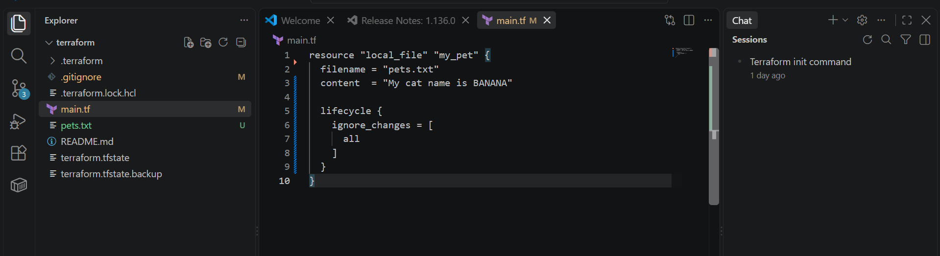
Then:
terraform fmt
terraform validate
terraform plan
terraform apply 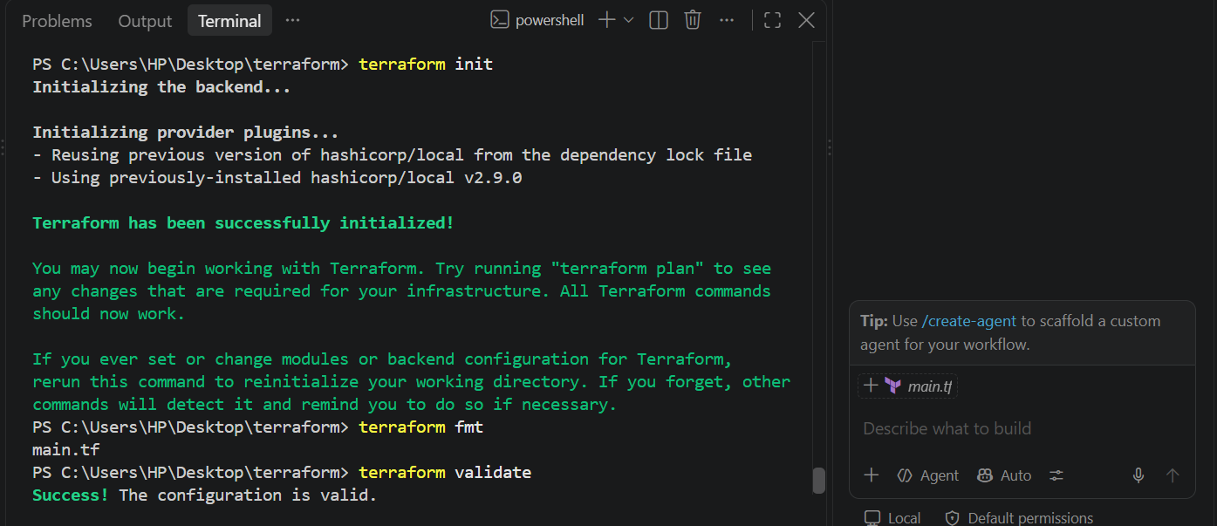 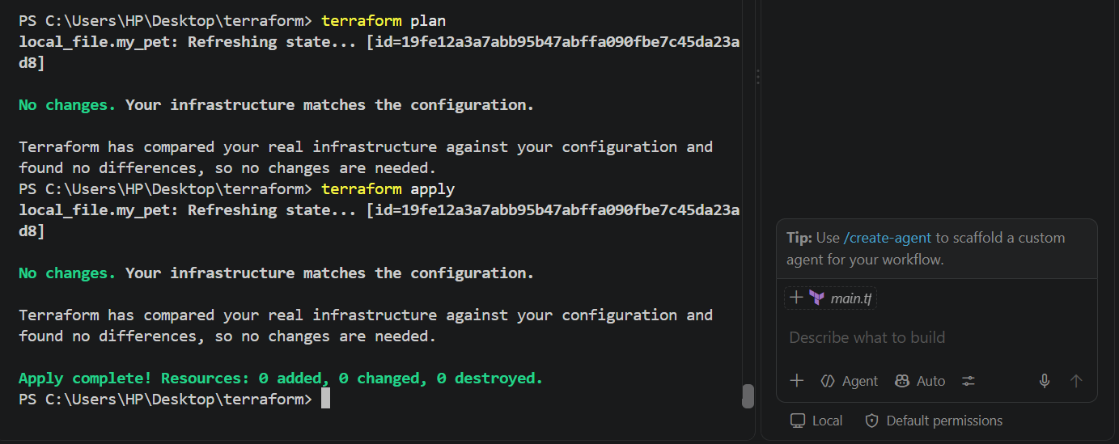
Terraform ignores the content difference.

19. Variables — next section of the video
The video then introduces variables.
Instead of hard-coding:
filename = "pets.txt"
we use:
filename = var.filename
Instead of:
content = "I love cats"
we use:
content = var.content

20. Create variables.tf
notepad variables.tf
Put:
variable "filename" {
default = "pets.txt"
type = string
}

variable "content" {
default = "I love cats"
type = string
}

variable "prefix" {
default = "MR"
type = string
}

variable "length" {
default = 1
type = number
} 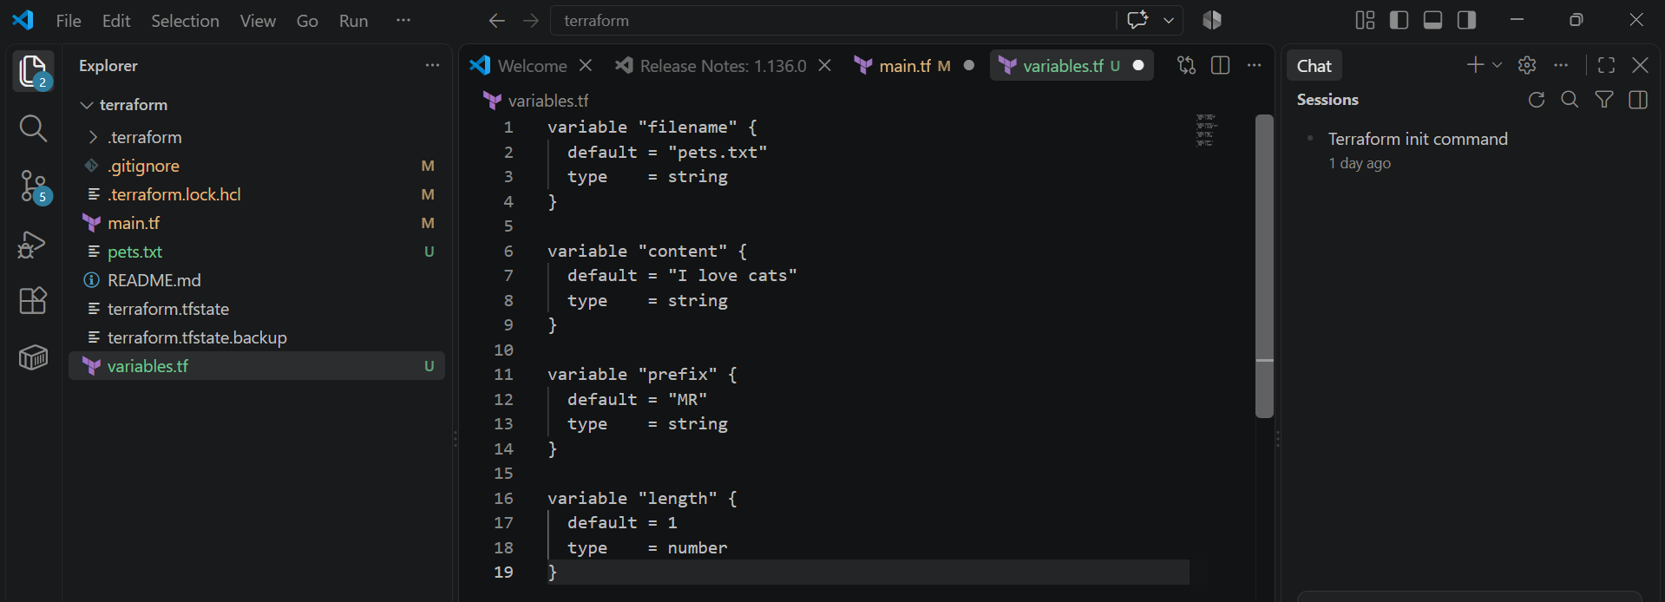

21. Modify main.tf
Use:
resource "local_file" "my_pet" {
filename = var.filename
content = var.content
}

resource "random_pet" "petname" {
prefix = var.prefix
separator = "."
length = var.length
} 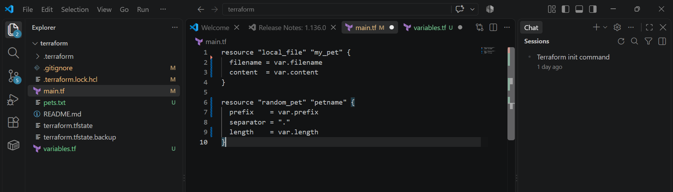
Now your project is:
Terraform_basic/
│
├── main.tf
├── variables.tf
├── pets.txt
└── terraform.tfstate

22. Execute variables
Run:
Terraform init
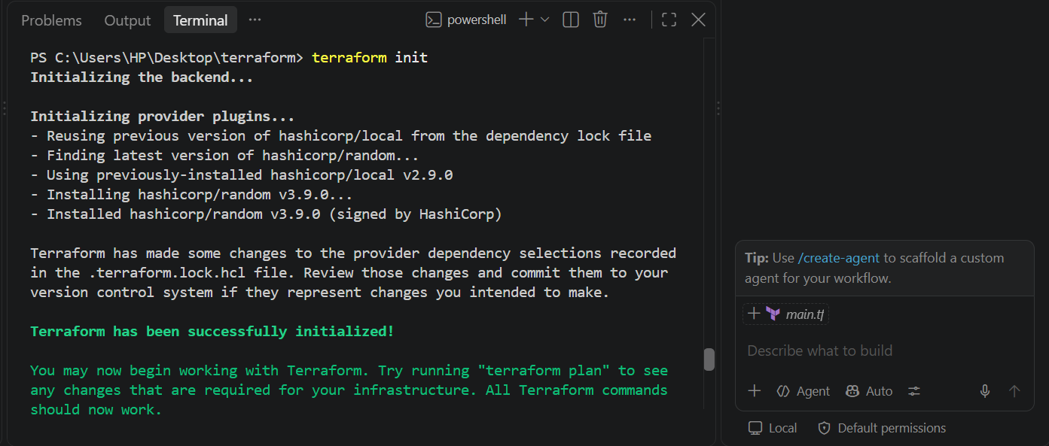
terraform fmt
terraform validate
terraform plan
terraform apply 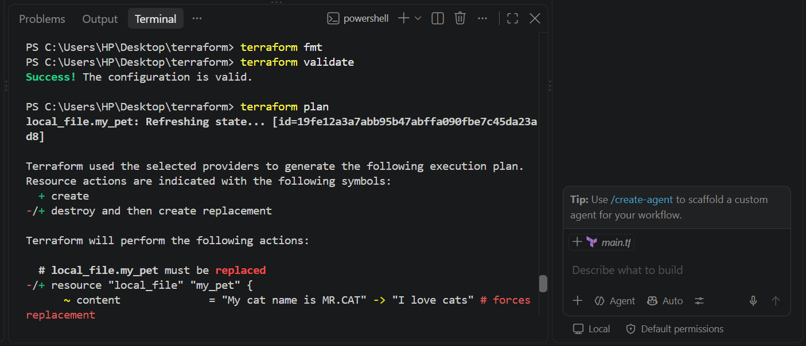 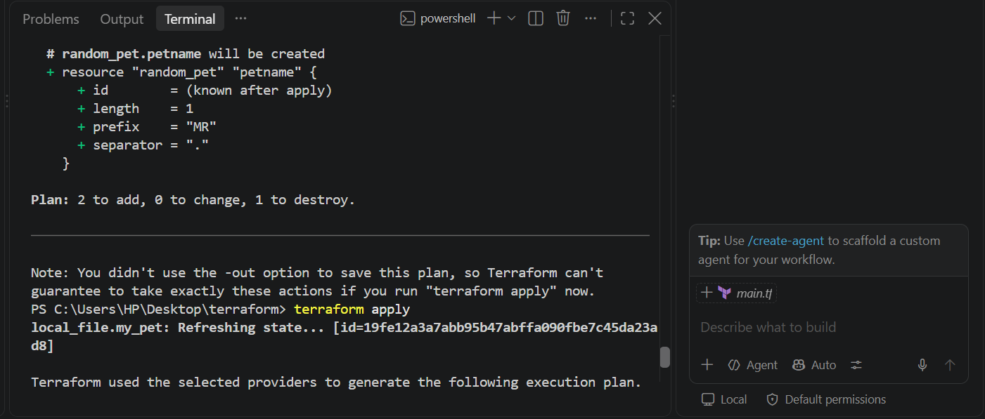 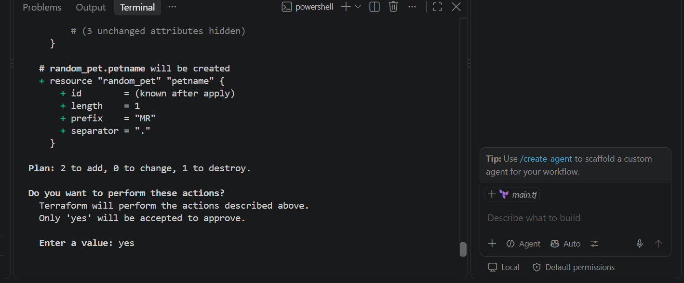 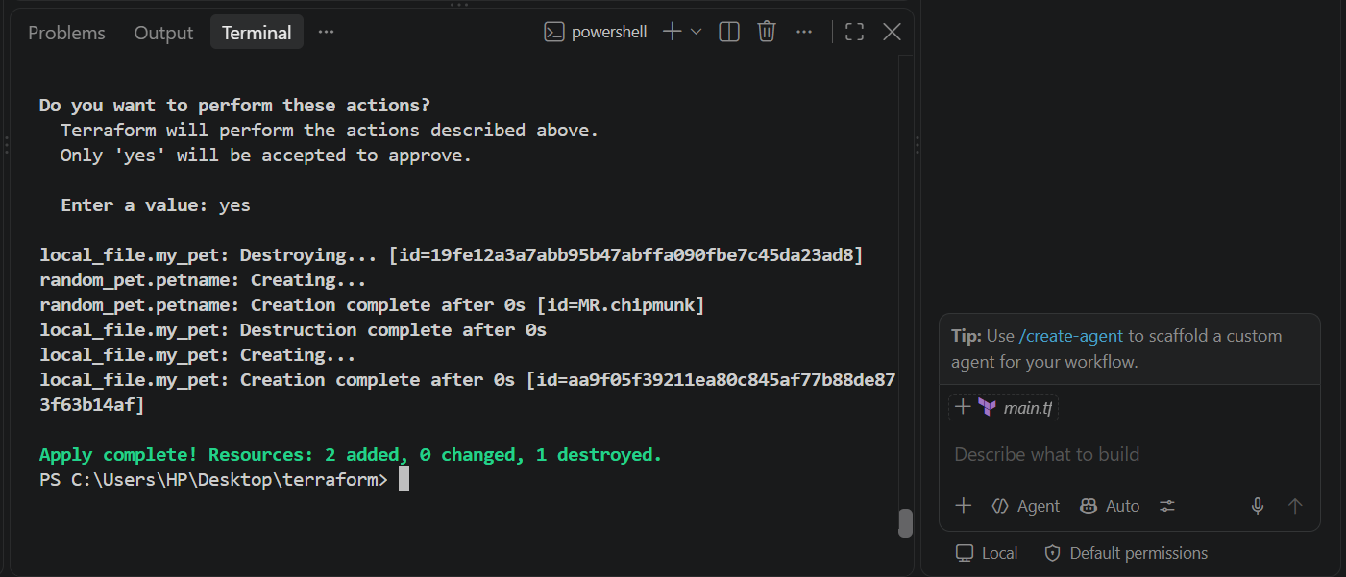
Terraform uses the default values:
filename = pets.txt
content = I love cats
prefix = MR
length = 1

23. Variable types shown in the video
The video explains these Terraform types:
Type | Example
string | "I love pets"
number | 1
bool | true / false
any | Any compatible value
list | ["cat", "dog"]
map | {pet1 = "cat", pet2 = "dog"}
object | Complex structured data
tuple | Ordered values of potentially different types
For your current practical, you mainly need:
type = string
and:
type = number

24. Passing variables
main.tf
resource "local_file" "my_pet" {
filename = var.filename
content = var.content
}

resource "random_pet" "petname" {
prefix = "MR"
separator = "."
length = 1
} 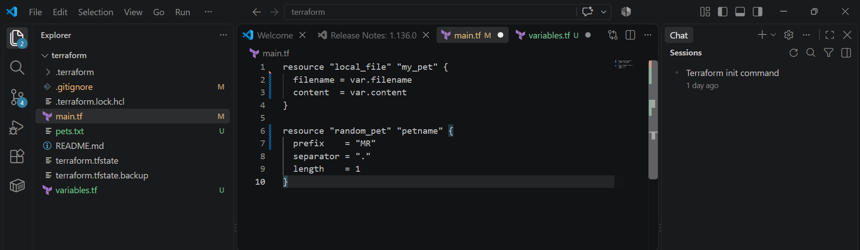
variables.tf
variable "filename" {
}

variable "content" {
} 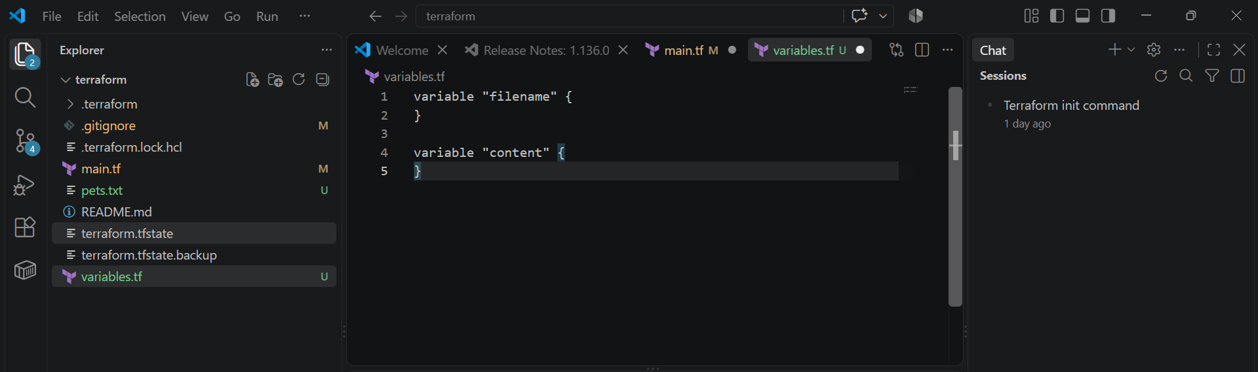
What this does
The main.tf uses two variables:
filename = var.filename
content = var.content
Since variables.tf only declares the variables and doesn't provide values, Terraform will ask you for the values when you run terraform apply.
The random_pet resource:
resource "random_pet" "petname" {
prefix = "MR"
separator = "."
length = 1
}
generates a random name such as:
MR.dog
MR.cat
MR.rabbit
Run it
First:
terraform init
Then:
terraform validate 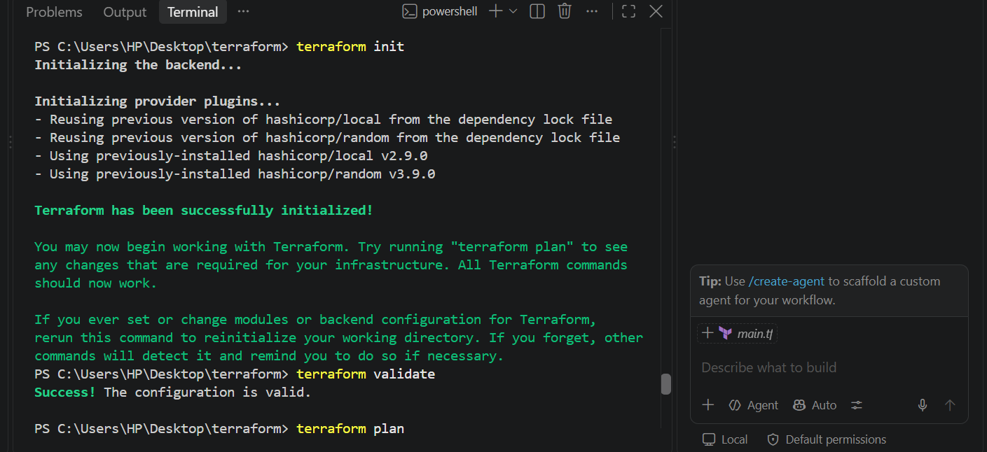
Then:
terraform plan 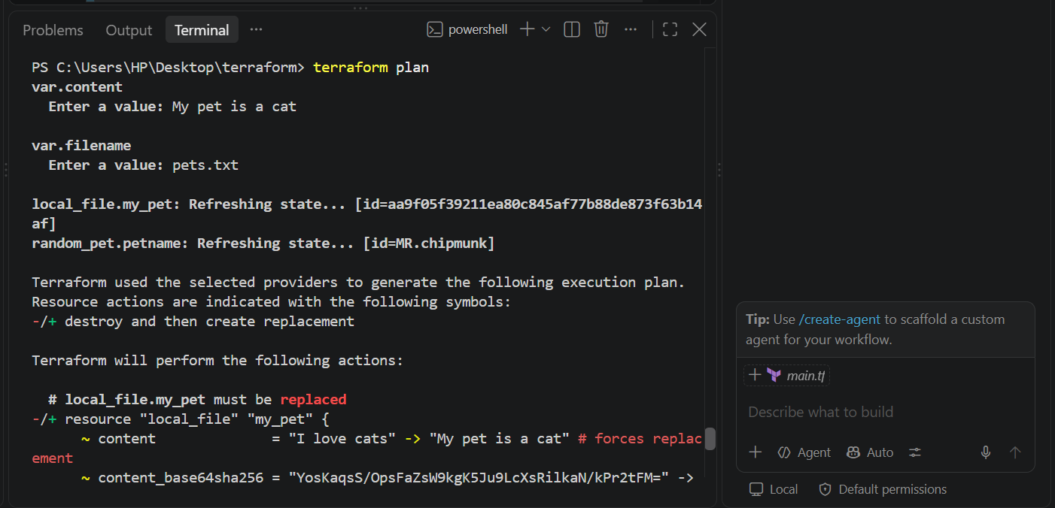 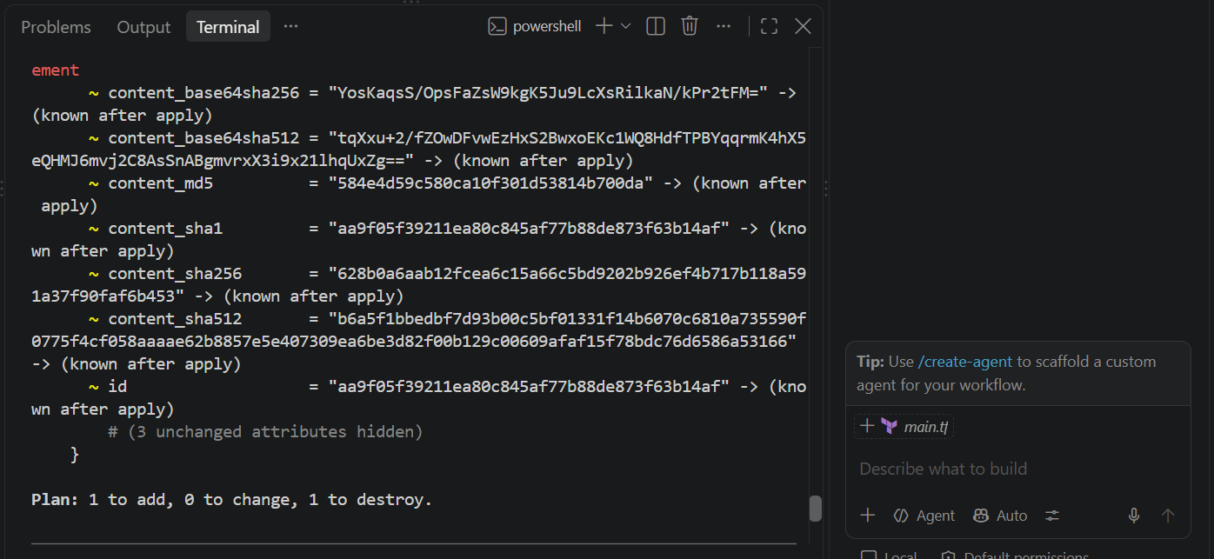
Finally:
terraform apply 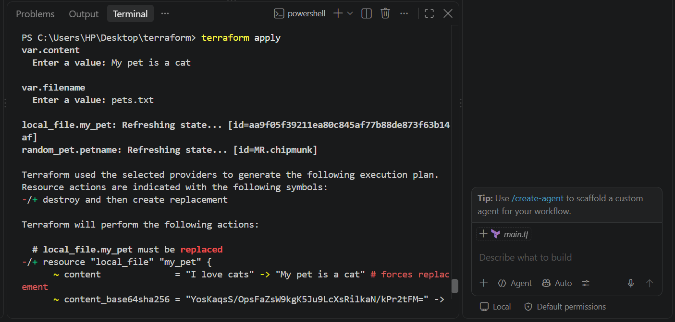 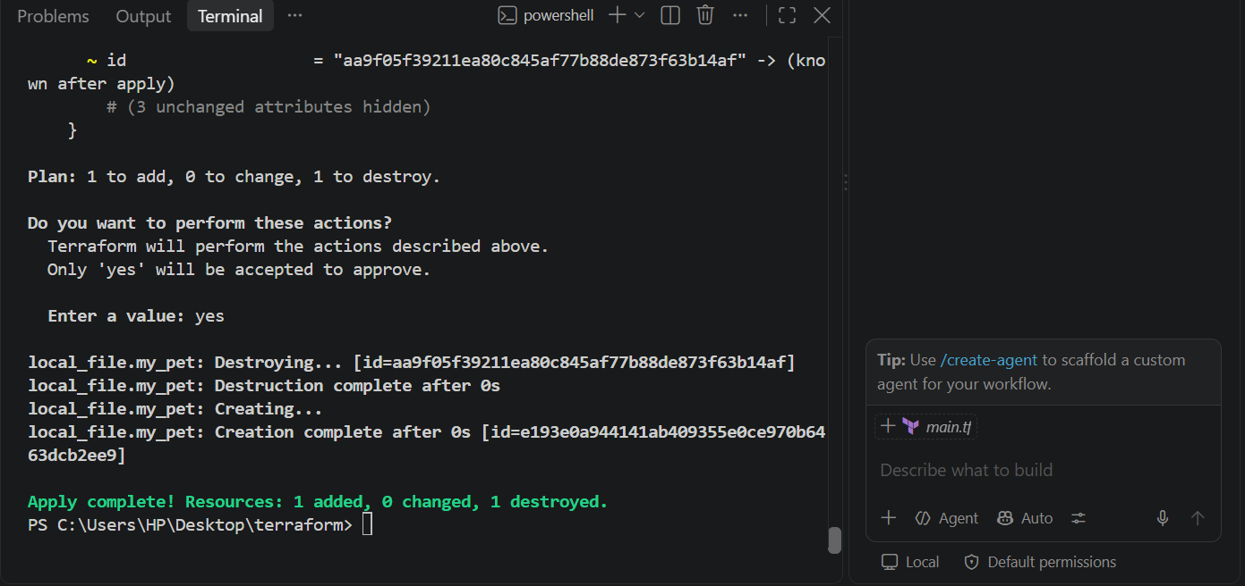
Terraform will ask:
var.filename
Enter a value:
Enter, for example:
pets.txt
Then:
var.content
Enter a value:
Enter:
My pet is a cat
Passing variables using -var:

Or else we can use the “terraform command line interface”

terraform apply -var="filename=wild.txt" -var="content=i love tiger"
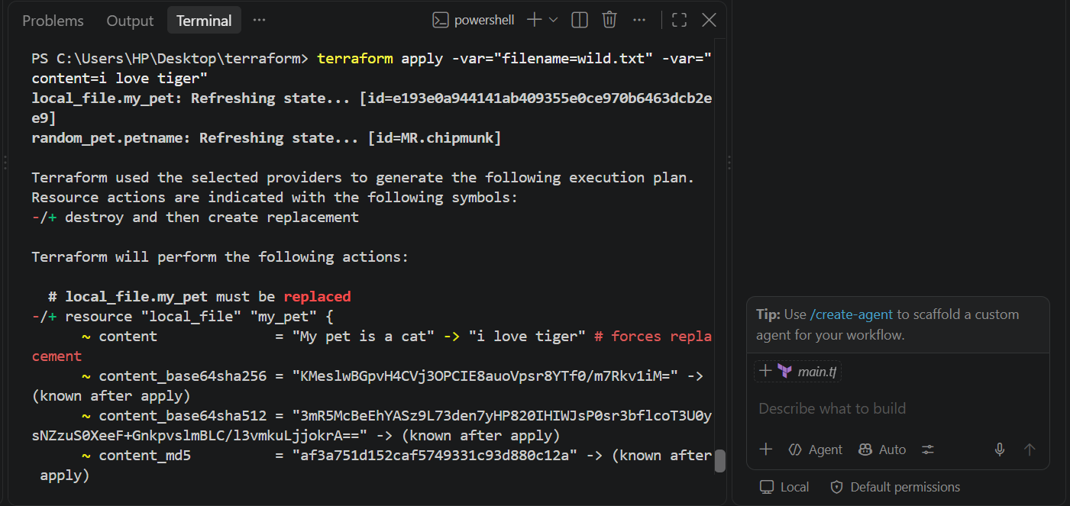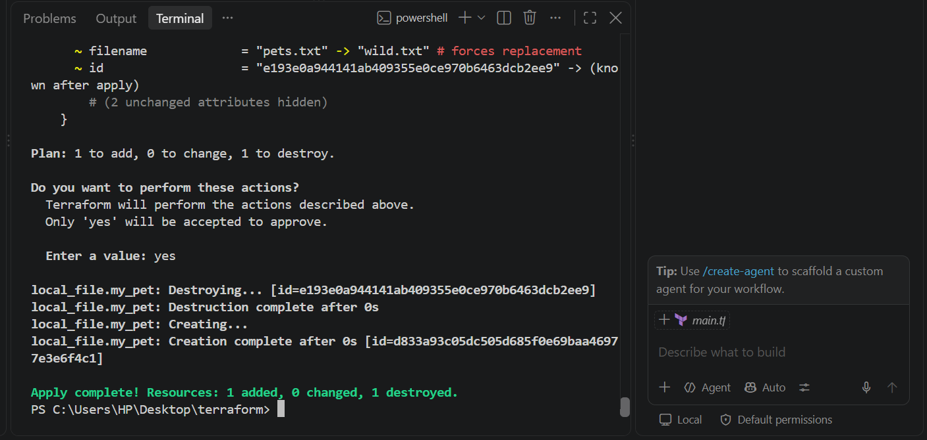

2). Integrate Terraform in Jenkins using the Terraform plugin?

Prerequisites
Before starting, your Jenkins server should have:
Jenkins
Terraform
Git
AWS CLI
AWS permissions
Check Terraform:
terraform version
Example:
Terraform v1.x.x
Check Git:
git --version
Check AWS:
aws --version
Check Java/Jenkins:
sudo systemctl status jenkins
You should see:
Active: active (running) 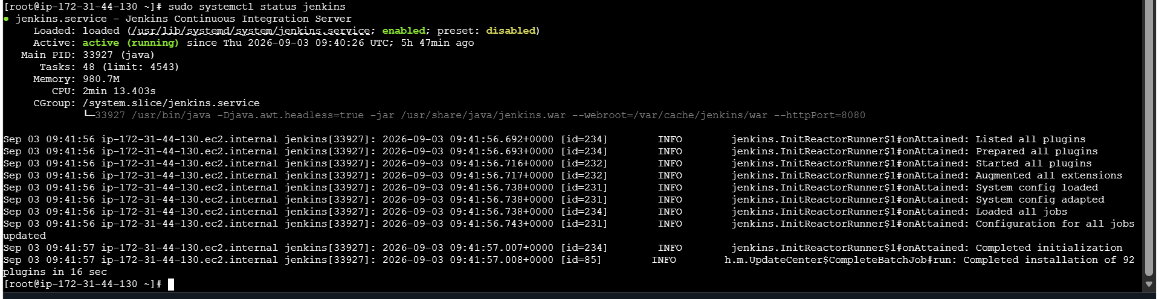

3. Make sure Jenkins can run Terraform
This is very important.
You may have Terraform working as ec2-user:
terraform version
but Jenkins runs as the jenkins user.
Test:
sudo -u jenkins terraform version 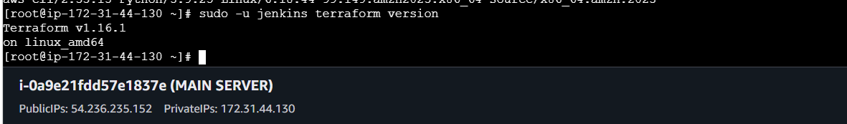

4. Give Jenkins access to AWS
Terraform needs AWS credentials.
For your EC2-based Jenkins setup, the recommended approach is to attach an IAM role to the Jenkins EC2 instance.
Then test:
aws sts get-caller-identity
Also test as Jenkins:
sudo -u jenkins aws sts get-caller-identity
You want this command to return the AWS account/identity available to the Jenkins process. 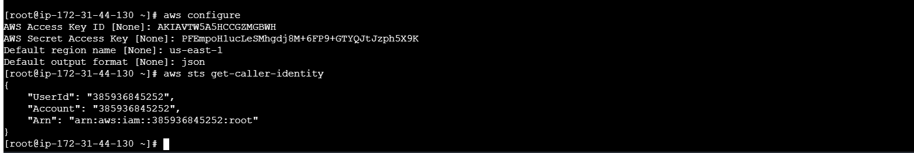

5. Create Terraform project
Let's use the Terraform code you were working with in the previous question.
Create a directory:
mkdir terraform-jenkins
cd terraform-jenkins
Create:
touch main.tf
touch variables.tf 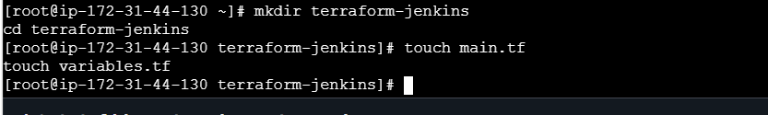

6. Put your main.tf in the project
For example:
resource "local_file" "my_pet" {
filename = var.filename
content = var.content
}

resource "random_pet" "petname" {
prefix = "MR"
separator = "."
length = 1
} 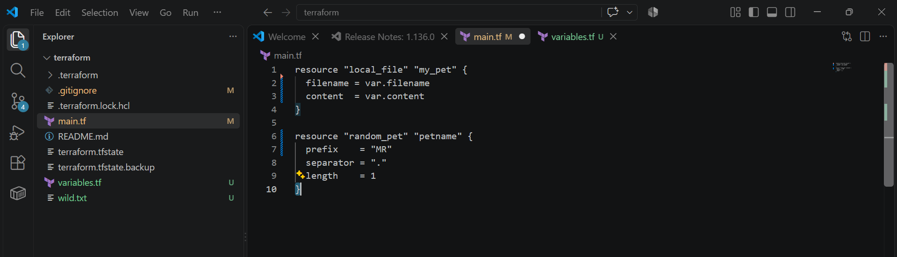

7. Put your variables.tf
variable "filename" {
}

variable "content" {
}
This is the same basic template you showed from the video. 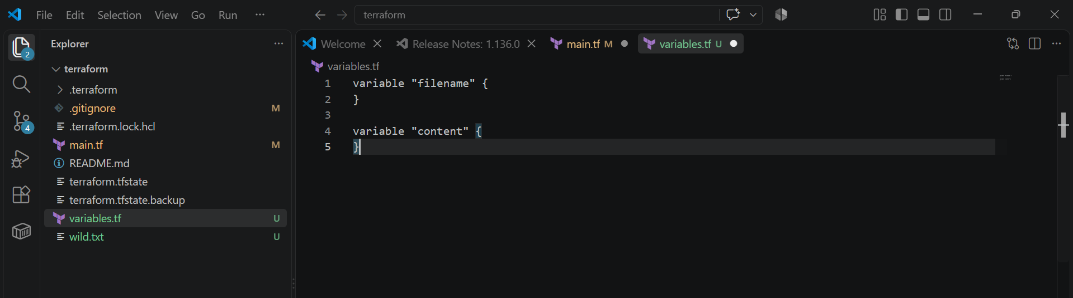

8. Test Terraform manually first
Before involving Jenkins, run:
terraform init 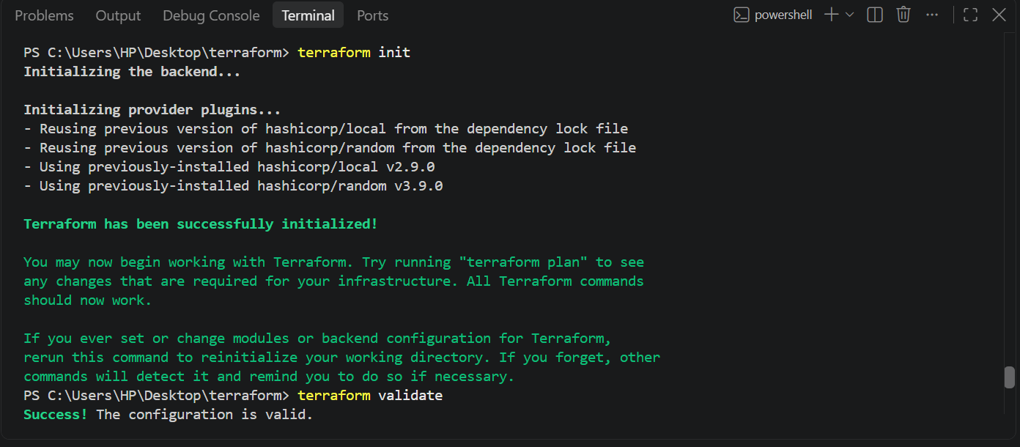
Then:
terraform validate
Then:
terraform plan 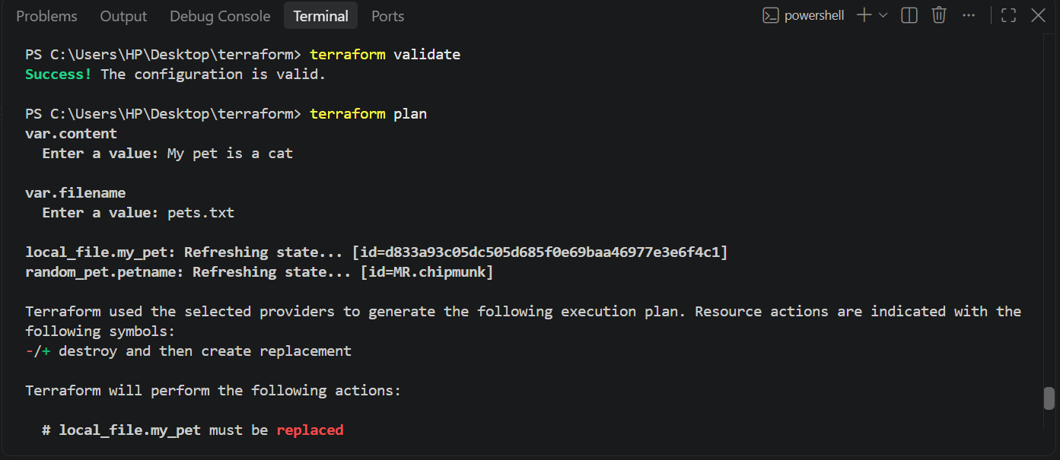
Then:
terraform apply 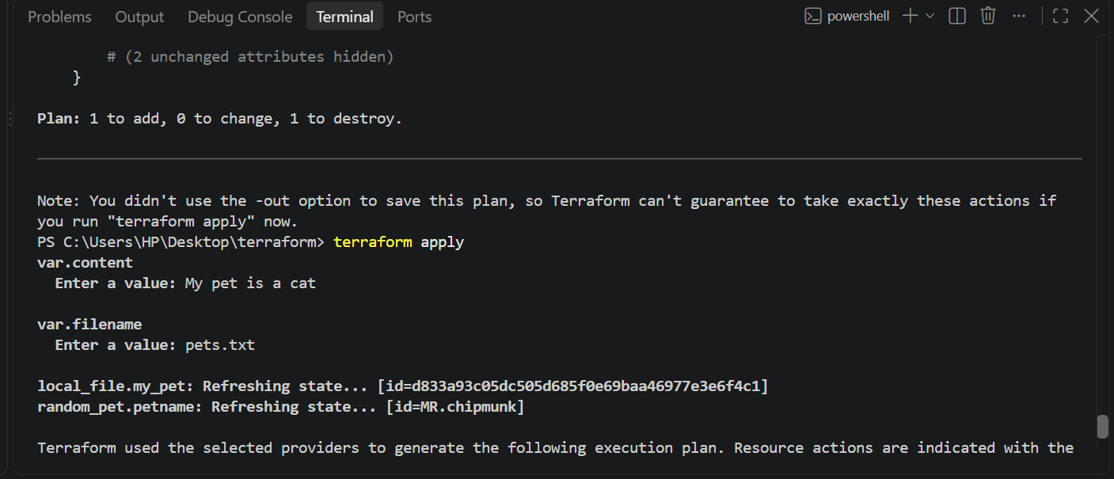 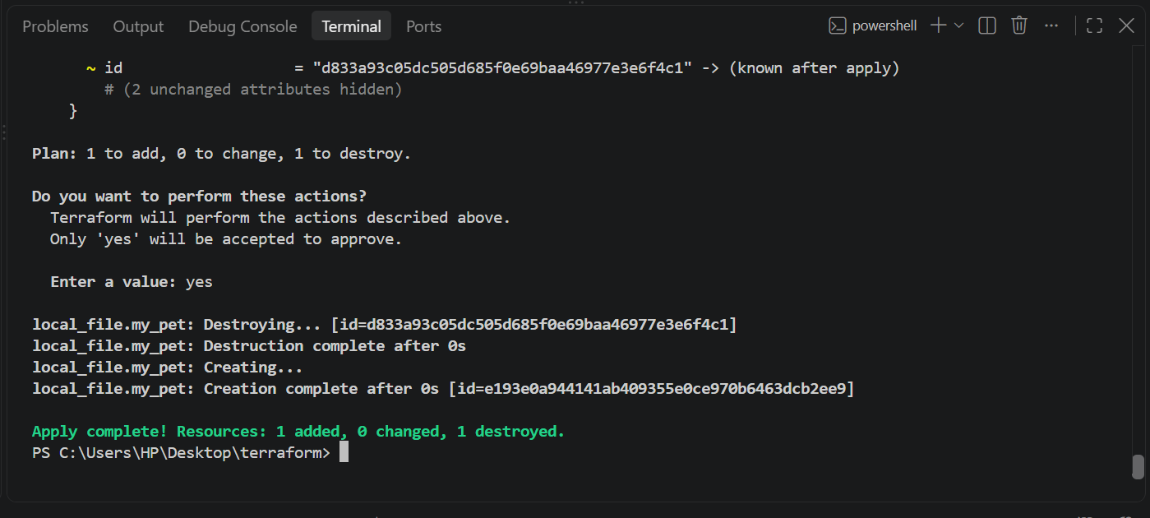
Terraform will ask:
var.filename
Enter a value:
Enter:
pets.txt
Then:
var.content
Enter a value:
Enter:
My pet is a cat

9. Push Terraform project to GitHub
Initialize Git:
git init
Add files:
git add .
Commit:
git commit -m "Add Terraform configuration"
Add your GitHub repository:
git remote add origin https://github.com/<USERNAME>/<REPOSITORY>.git
Push:
git branch -M main
git push -u origin main 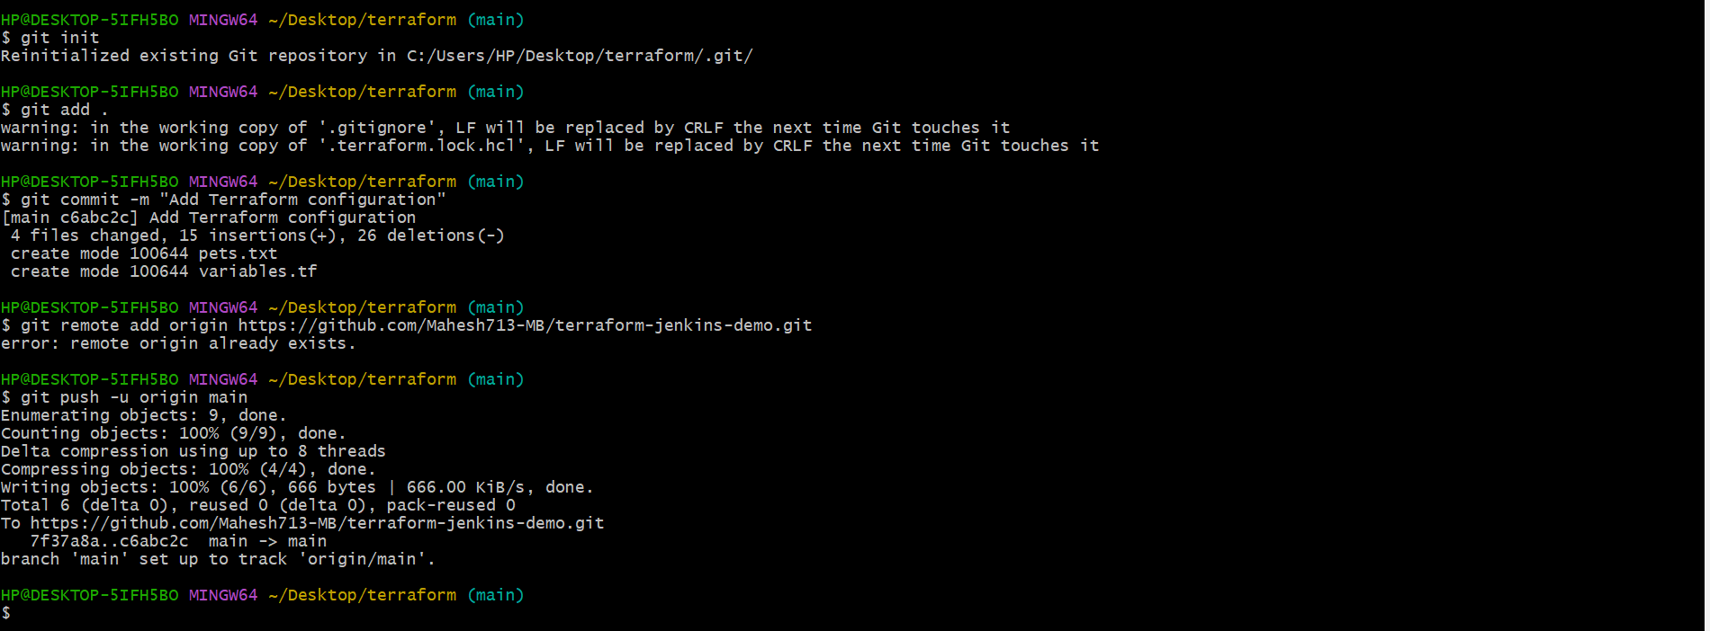
Your GitHub repository should now contain:
terraform-jenkins/
│
├── main.tf
└── variables.tf

10. Install Terraform plugin in Jenkins
Open Jenkins:
http://<JENKINS-IP>:8080
Go to:
Manage Jenkins
↓
Plugins
↓
Available plugins
Search:
Terraform
Install:
Terraform
The official plugin page identifies the plugin ID as:
terraform
and documents its Terraform configuration/build-wrapper functionality. 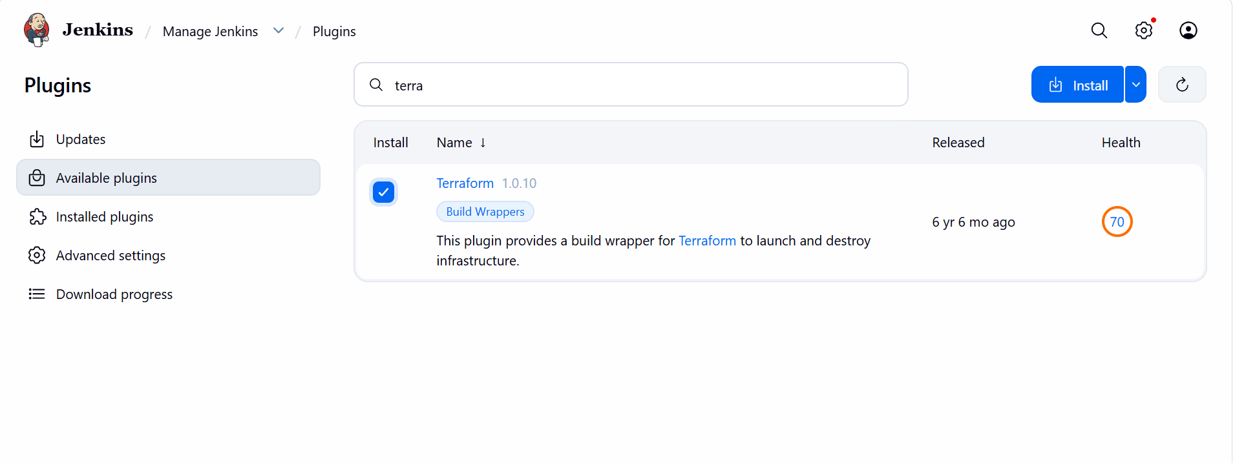 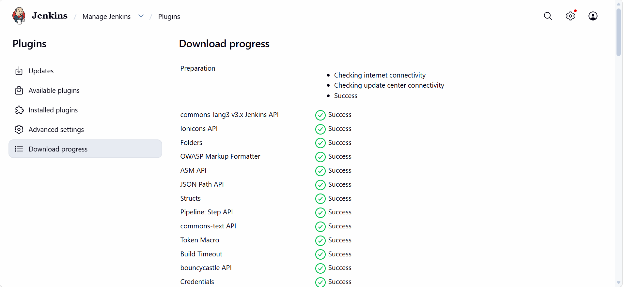

11. Configure Terraform in Jenkins
Go to:
Manage Jenkins
↓
Tools
Look for:
Terraform installations
Click:
Add Terraform
Give it a name:
terraform
Depending on your Jenkins/plugin version, you may see an installer option.
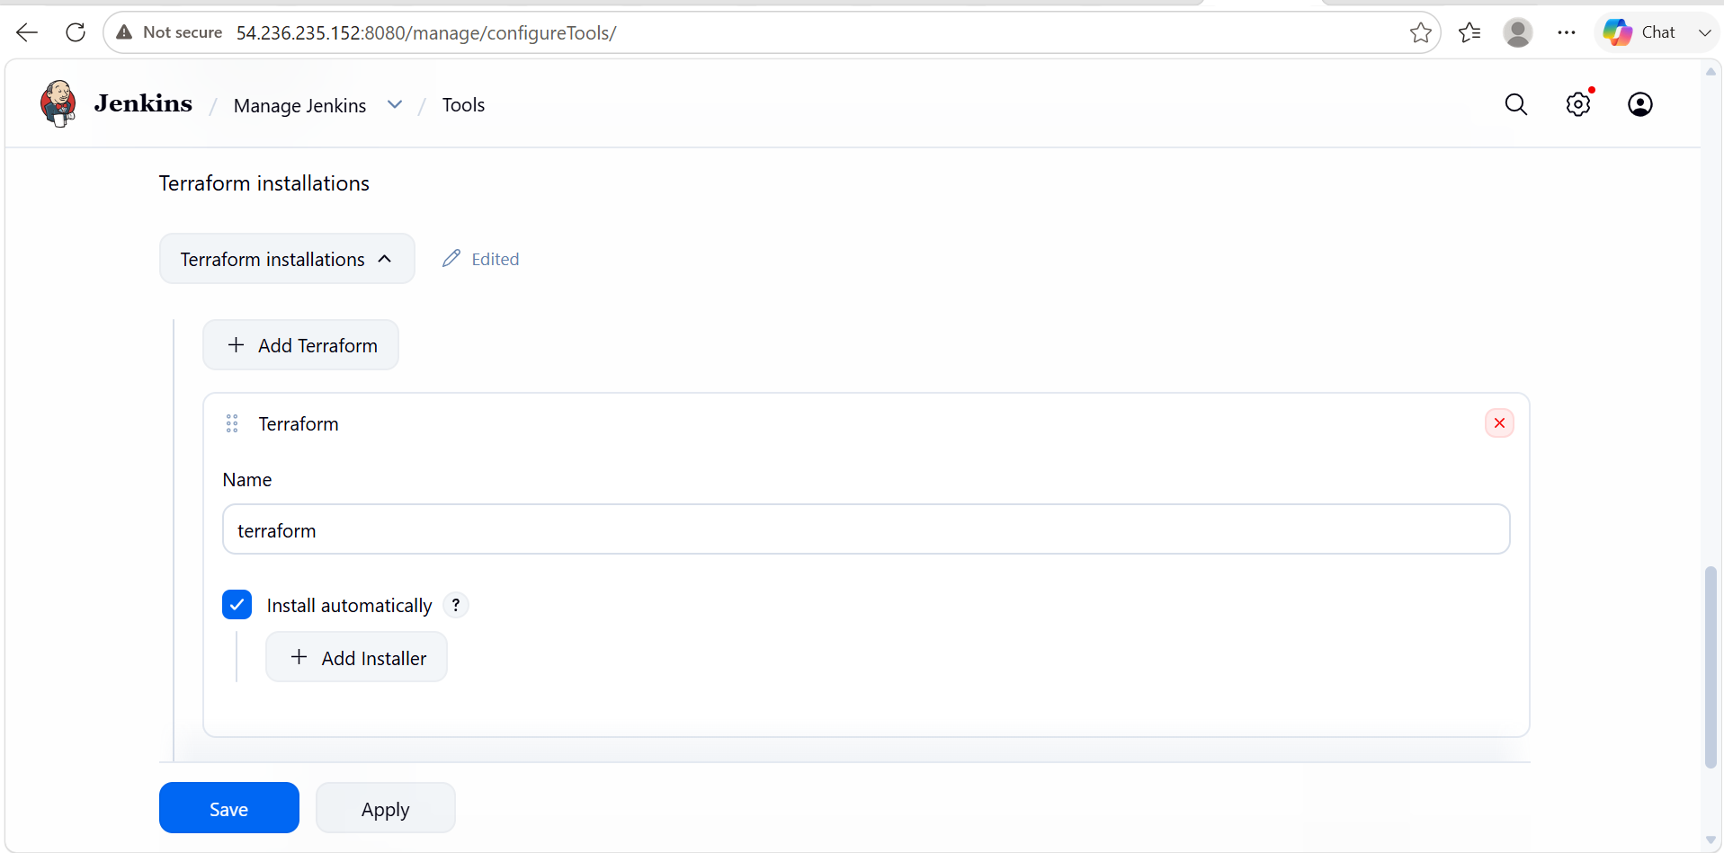

12. Create Jenkins Pipeline job
Go to:
Jenkins Dashboard
↓
New Item
Enter:
terraform-jenkins
Select:
Pipeline
Click:
OK
Jenkins Pipeline is designed to define the CI/CD workflow as code, commonly in a Jenkinsfile. 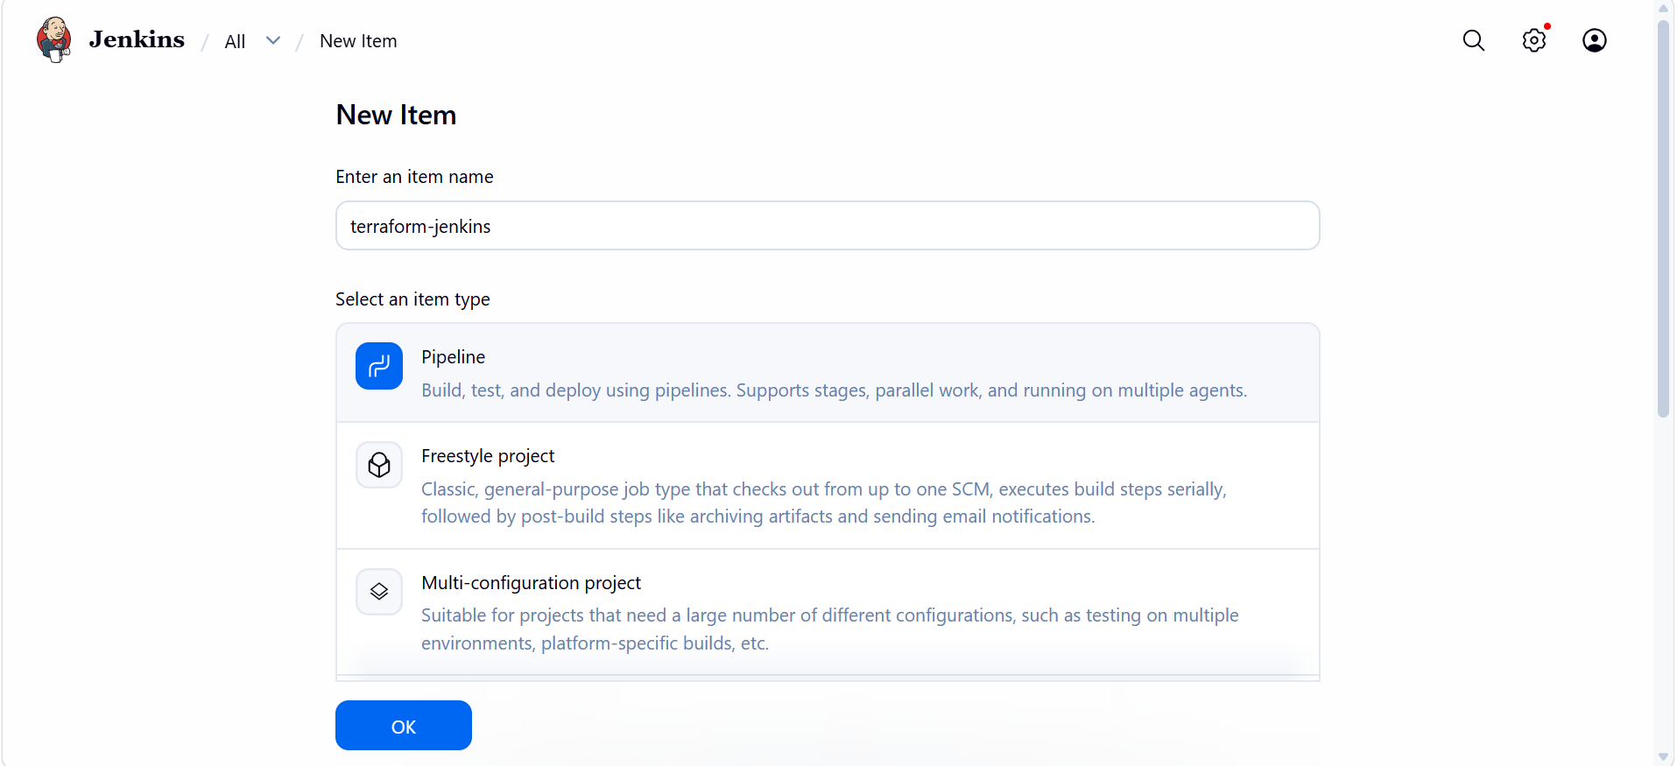

13. Configure GitHub
Inside the Jenkins job:
Pipeline
For a simple practical, choose:
Definition:
Pipeline script
We can directly paste the pipeline.
Alternatively, the better real-world approach is:
Definition:
Pipeline script from SCM
Then:
SCM:
Git
Repository:
https://github.com/<USERNAME>/<REPOSITORY>.git
Branch:
*/main
Script Path:
Jenkinsfile

14. Simple Jenkins Pipeline
For your practical, start with this:
pipeline {

agent any

stages {

stage('Checkout') {
steps {
git branch: 'main',
url: 'https://github.com/<USERNAME>/<REPOSITORY>.git'
}
}

stage('Terraform Version') {
steps {
sh 'terraform version'
}
}

stage('Terraform Init') {
steps {
sh 'terraform init'
}
}

stage('Terraform Validate') {
steps {
sh 'terraform validate'
}
}

stage('Terraform Plan') {
steps {
sh 'terraform plan'
}
}
}
}
Replace:
<USERNAME>
<REPOSITORY>
with your GitHub details. 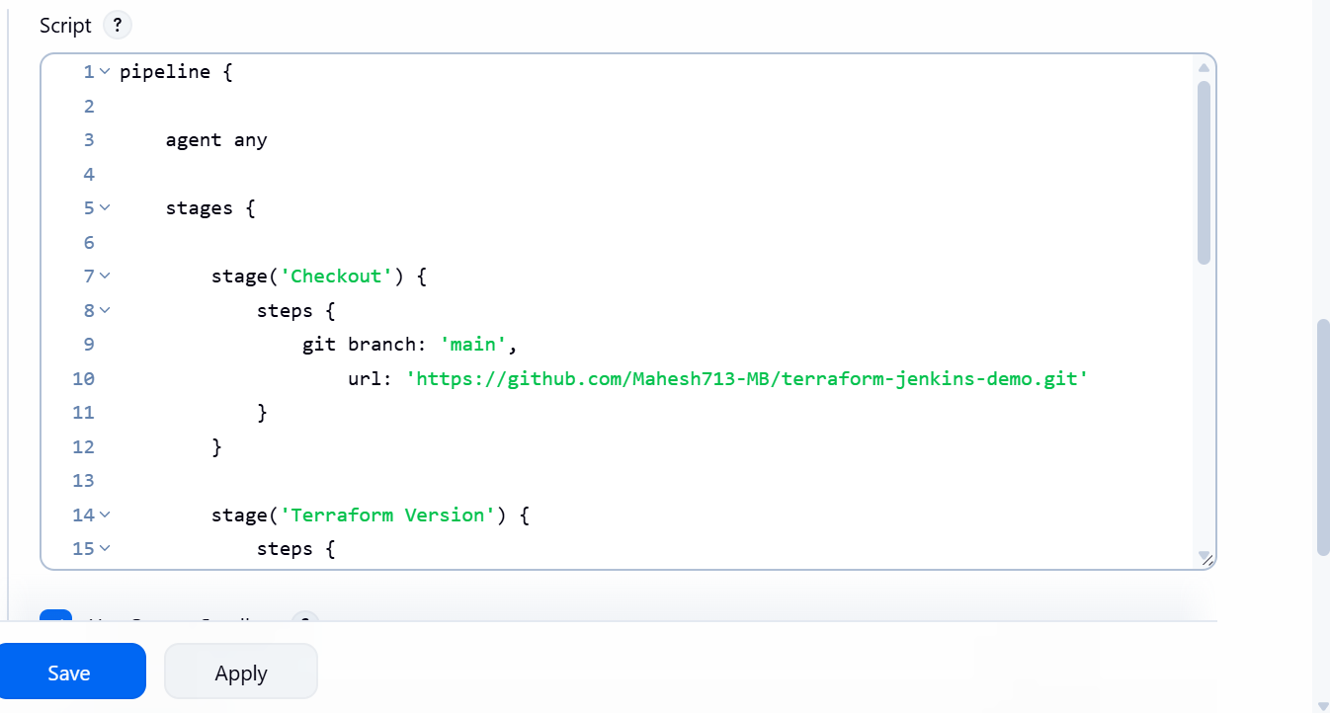 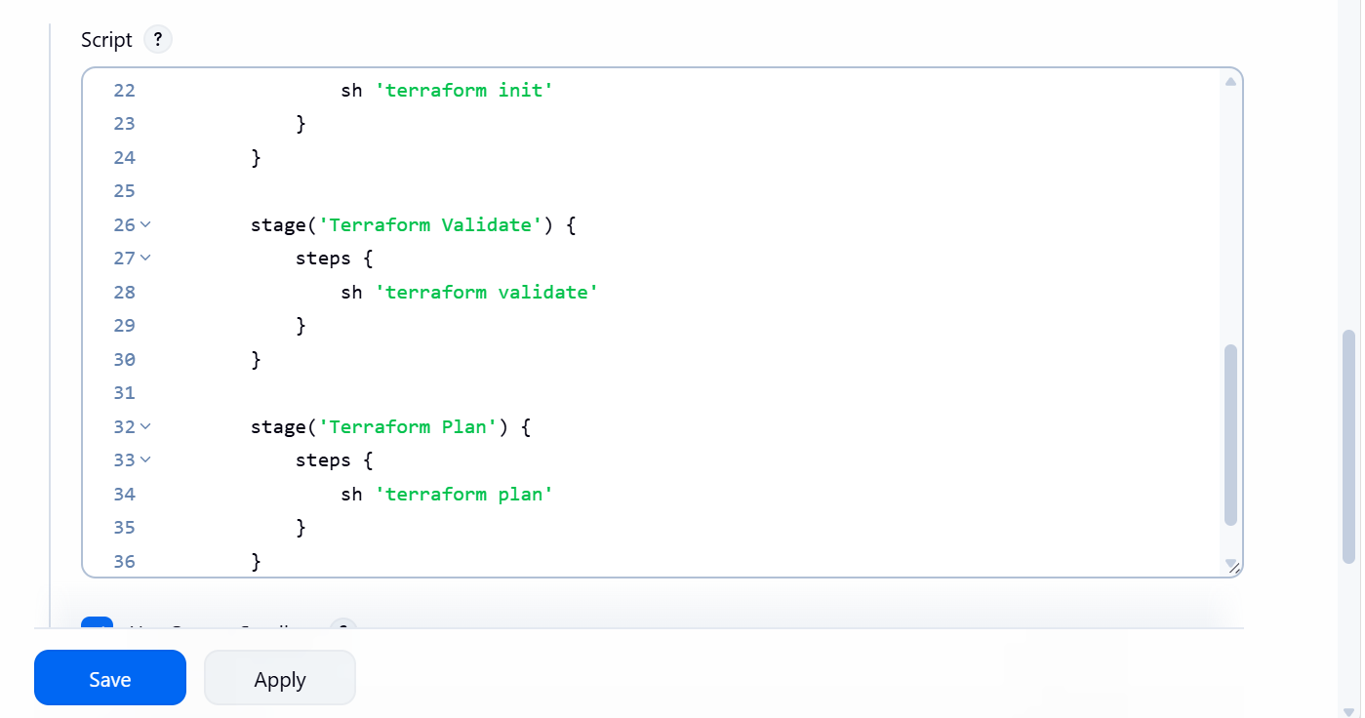

15. Click Build Now
Save the Jenkins job.
Click:
Build Now
Then:
Build #1 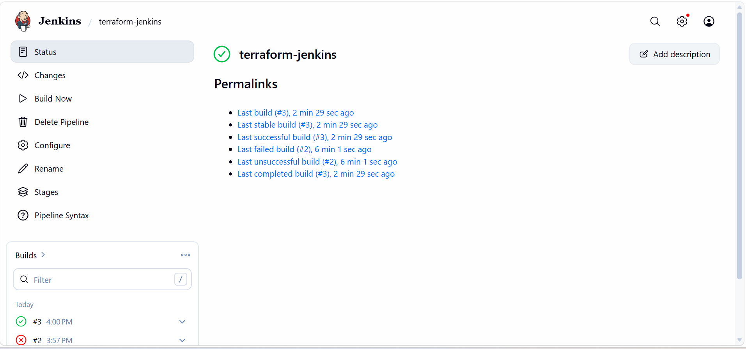
↓
Console Output
Jenkins should perform:
Checkout
↓
Terraform Version
↓
Terraform Init
↓
Terraform Validate
↓
Terraform Plan
You should see:
Terraform v1.x.x
then:
Terraform has been successfully initialized!
then:
Success! The configuration is valid. 